Step-By-Step Instructions

**Self-Study Report (SSR)**

The self-study template is an Excel document. The required documentation must be named exactly as listed and in the specified file format. However, most of the documents will require the file format to be an Adobe Acrobat Document (PDF). **If the documentation is not named exactly as directed and in the correct file format, then the self-study will be returned and the program must fix the naming/formatting issues identified before the CoAEMSP will accept it.**

Cloud-based services (i.e., SharePoint, Google Docs, etc.) must not be used when completing the self-study template. This type of software tends to remove the built-in formulas from Excel.

Please be sure the documentation is positioned so that it does not need to be rotated to view and the ability to rename a folder and/or document is not restricted.

Throughout the self-study template, if the CoAEMSP has a form available for sponsors to use, the following purple note will identify there is a form and the name of the form is displayed with a link to the form location on the right.

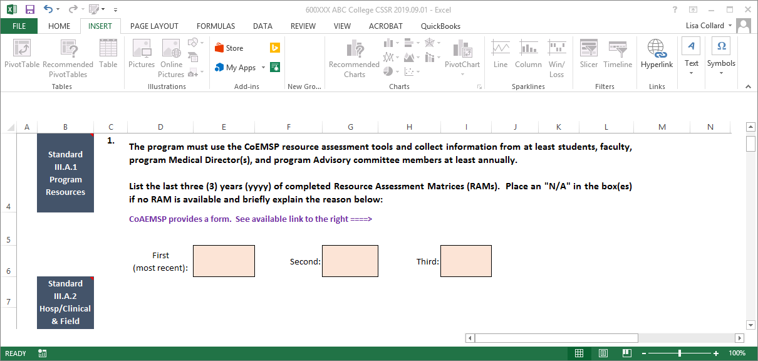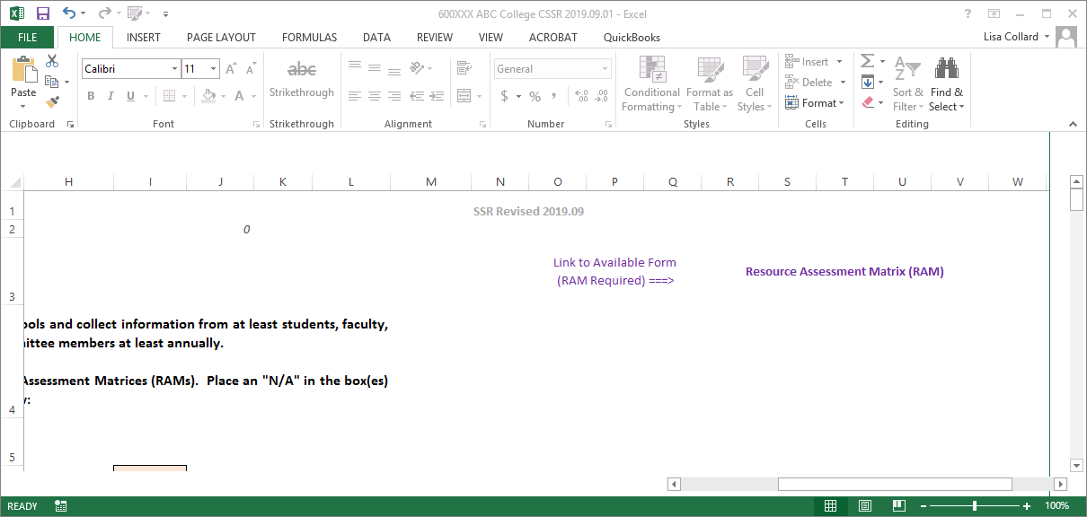

Please use the steps on the following pages as a guide in completing the self-study along with the documents checklist located at the end of these instructions.

Left click on the PDF icon below so it is outlined (highlighted), then double-click on it to access the Directions for Creating a Single PDF Document.



*\*\*\*Remember to save your work often as you complete the Excel template\*\*\**

*For questions or help composing the self-study, please contact Lisa Collard (*[*lisa@coaemsp.org*](mailto:lisa@coaemsp.org) *or 214-703-8445 ext. 118)*

1. Download and save the correct self-study template to your desktop.

For programs that have a six-digit program number (e.g., Paramedic 60XXXX, AEMT 20XXX or 21XXX) and hold an accreditation status, download the self-study identified in the notification email received from the CoAEMSP [i.e., Self-Study Report – Initial (ISSR) or Continuing (CSSR)].

*For programs that do not currently hold a status and are seeking the Letter of Review, verify the Self-Study Report – Letter of Review (LSSR) has been downloaded.*

1. Create a main folder on your desktop titled with the Program #, self-study template [i.e., ISSR or CSSR], and Submission Due Date [yyyy.mm.dd].

(*e.g.,* ***600XXX CSSR 20XX.10.01***).

*Letter of Review Self-Study Report (LSSR) submissions will not have a Program # and will need to title the main folder with the invoice number which will also contain at least a letter (e.g., A, P,AP, or PA) indicating the educational level (e.g., 5-digit # LoR) used to title the LoR Application, SSR, and Submission Date (e.g.,* ***2X011PA LoR SSR 20XX.05.14****)*.

1. Open the main folder and create **one** sub-folder for the requested documentation titled **Documentation**.
2. Name the self-study template the same as the main folder Program #, self-study template [i.e., ISSR or CSSR], and Submission Due Date [yyyy.mm.dd]. (*e.g.,* ***60XXXX CSSR 20XX.10.01***).

*Letter of Review Self-Study Report (LSSR) submissions, title the template the same as the main folder (e.g.,* ***2X011PA LSSR 20XX.05.14****).*

The main folder should look like the example(s) below after completing Steps 1-4 above.

**Main folder**

*Main folder for CSSR would show 60XXXX CSSR 20XX.10.01*

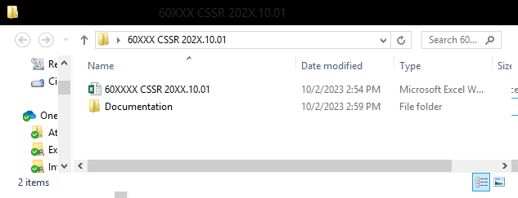

**Renamed Excel Template**

*Renamed CSSR Excel template would show 60XXXX CSSR 20XX.10.01*

**Single sub-folder**

**Main folder**

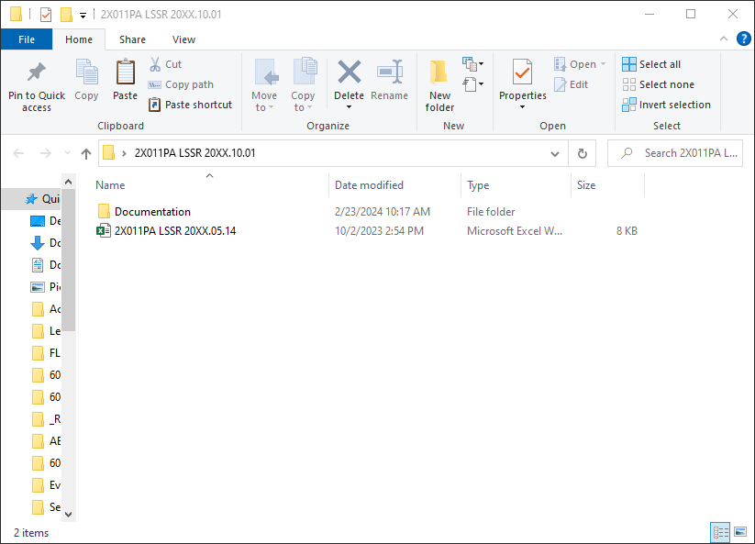

*Main folder for LSSRs would show 2X011PA LSSR 20XX.05.14*

**Renamed Excel Template**

*Renamed LSSR Excel template would show 2X011PA LSSR 20XX.05.14*

**Single sub-folder**

1. Open the self-study template and begin by completing all light orange text boxes on the Title Page and Program Info tabs. All blue text boxes will automatically populate data once the associated tab has been completed. Data cannot be placed directly into the blue text boxes. **Please Note: Cloud-based services (i.e., SharePoint, Google Docs, etc.) must not be used when completing the self-study template. This type of software tends to remove the built-in formulas from Excel.**

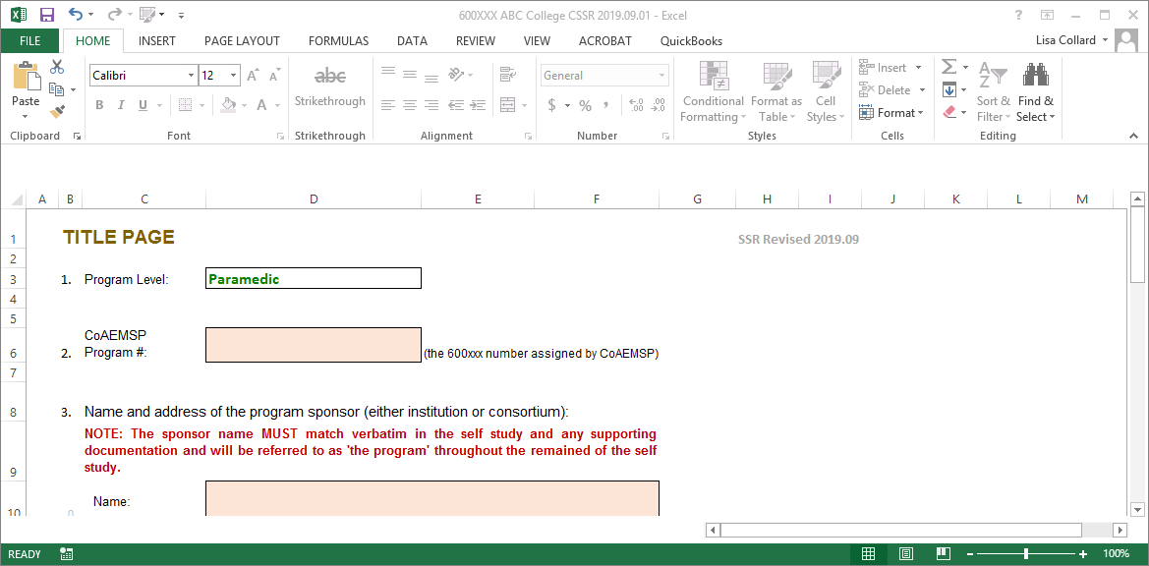 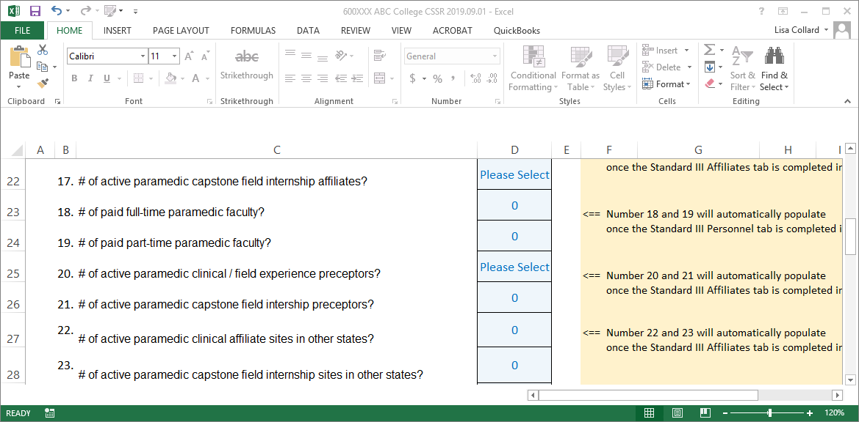

**Blue Text Boxes**

**Light Orange Text Box**

1. Continue to the Standards I tab and complete the light orange text boxes. Please keep in mind, the template has built in logic and some questions may appear to be incomplete (e.g., Standard I question 4). However, the question will populate based on how the sponsor answers previous questions (e.g., questions 1 through 3) so it is important to complete the tabs in order rather than skipping around. The blue box directly above the dark orange section identifies the documentation needed and the dark orange section identify the specific name and format required to be used when including the file in the **Documentation** sub-folder. The required documentation MUST be titled with the 'EXACT document name' and the type of file format that MUST be used (see picture below). **Please Note: If the documentation is not named exactly as directed and in the correct file format, then the self-study will be returned and the program must fix the naming/formatting issues identified before the CoAEMSP will accept it. Cloud-based services (i.e., SharePoint, Google Docs, etc.) must not be used when completing the self-study template. This type of software tends to remove the built-in formulas from Excel.**

If the documentation consists of more than a single page, the documentation must be scanned and included as a single PDF document in the **Documentation** sub-folder. **Please Note: Directions for Creating a Single PDF Document can be accessed on page 1 of these instructions by double-clicking on the PDF icon in green.**

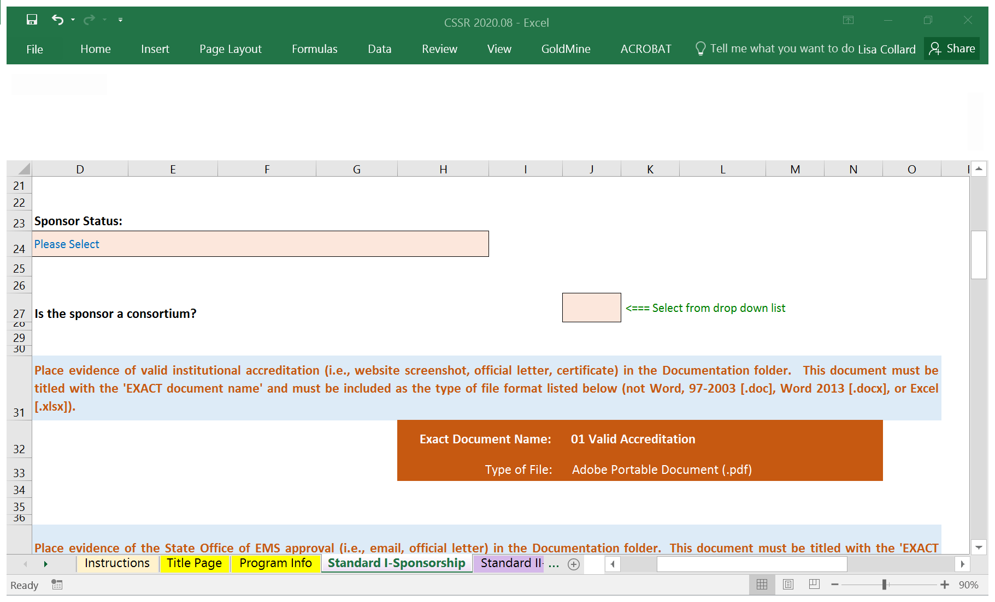

1. Continue to the next tab(s) (i.e., Standards II-V and Alternate & Satellite Locations), complete the light orange text boxes, gather the specific documentation in the format outlined in the dark orange sections, and name the document as specified to be included in the **Documentation** sub-folder. Again, the questions and data provided populate based on how the sponsor answers previous questions and provides data so it is important to complete the tabs in order rather than skipping around.
2. Additionally, the Standard III-Personnel tab requires the Personnel Verification document to be included in the **Documentation** sub-folder as evidence (i.e., 17 Personnel). The CoAEMSP sends this form once the key program personnel have been verified. **The Personnel Verification will not be provided until all required personnel documentation has been verified.** If any Program personnel need to be updated, please follow the instructions for submitting the required documentation for that specific key personnel as outlined on the Personnel page of the CoAEMSP website (<https://coaemsp.org/personnel>). [see Standard III – Personnel tab for more details].
3. The **Documentation** sub-folder should look like the following picture(s) as documentation for the Standard I tab is included. *Please note, if the sponsor only awards an Associate Degree and does not have any articulation agreements, then the Certificate-Diploma, Baccalaureate Degree, Master’s Degree, and articulation agreements will not be required to be place in the* ***Documentation*** *sub-folder for Standard I.*

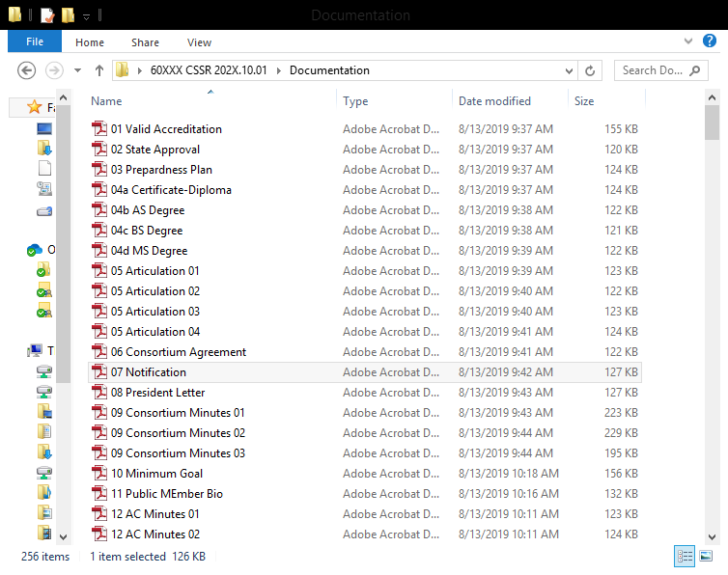

**Documentation sub-folder with the requested documentation for Standard 1, if applicable.**

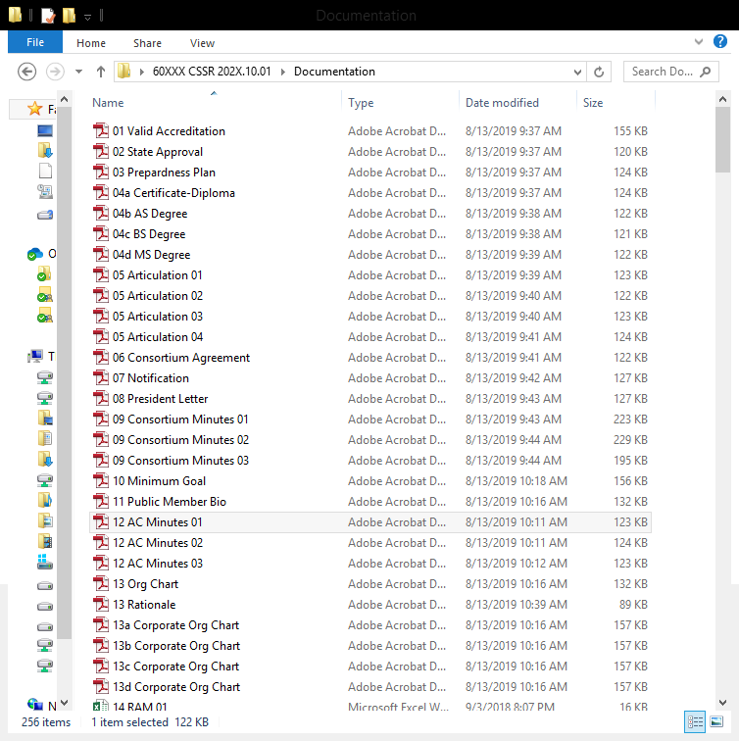

**Documentation sub-folder for Consortia Sponsors ONLY with the additionally requested documentation for Standard 1, if applicable.**



1. Once all tabs have been completed, verify all the requested documentation has been gathered, properly named and formatted, and included in the **Documentation** sub-folder. The **Documentation** sub-folder will have many files once all the documentation has been included for each of the remaining tabs. However, each program’s **Documentation** sub-folder will vary some and will be based on the information for that specific program’s completed self-study template. If every document was required to be included in the **Documentation** sub-folder from the Standard I, Standard II, and part of Standard III tabs 9i.e., resources and personnel), then it would look like the following example except it would appear as a single column. Upon completion of the self-study, the **Documentation** sub-folder will have many more documents than pictured on the following page.

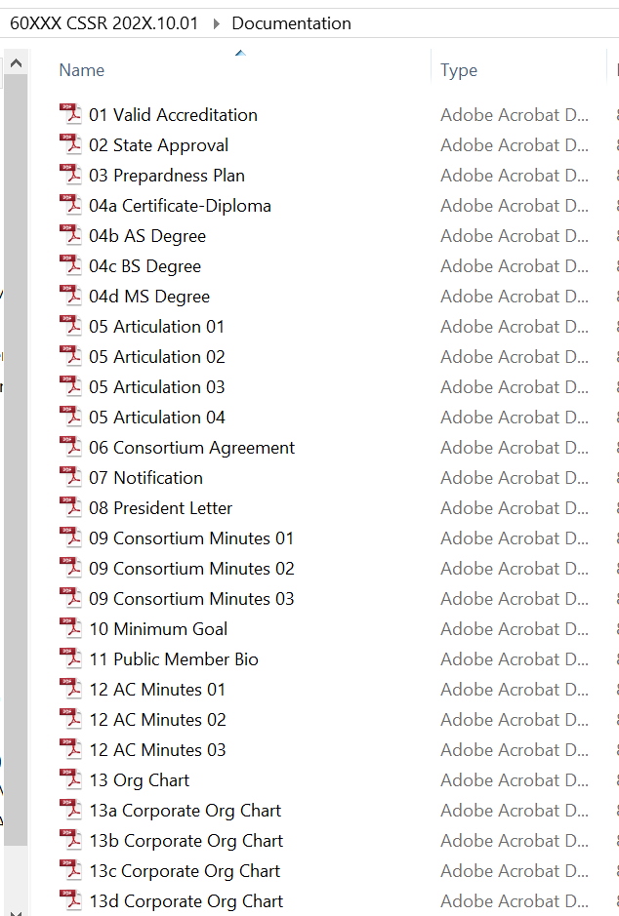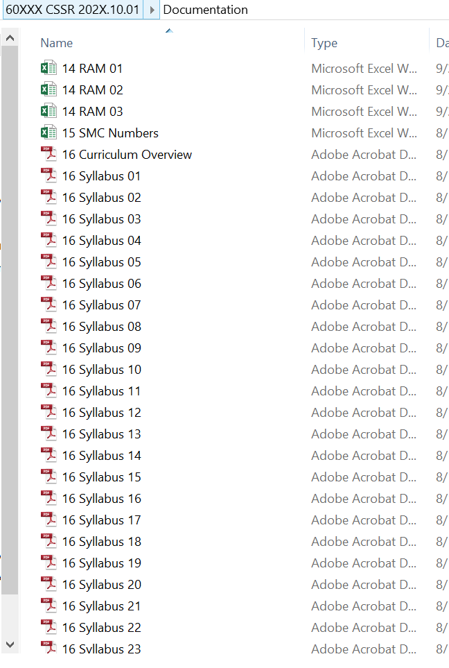

1. Please review the self-study template and required documentation to verify the information provided is correct and has been named and formatted correctly, as well as, review it with the Dean and any other required personnel. Please contact Lisa Collard ([lisa@coaemsp.org](mailto:lisa@coaemsp.org) or 214-703-8445 ext. 118)at the CoAEMSP with any questions.

**Please Note: If the documentation is not named exactly as directed and in the correct file format, then the self-study will be returned and the program must fix the naming/formatting issues identified before the CoAEMSP will accept it. Cloud-based services (i.e., SharePoint, Google Docs, etc.) must not be used when completing the self-study template. This type of software tends to remove the built-in formulas from Excel.**

1. The self-study is ready to be submitted. Zip (compress) the **entire** main folder. Upload the zipped (compressed) folder to the sponsor’s fileshare account (<https://coaemsp.sharefile.com/Authentication/Login>) **no later than the due date** which was provided in the CoAEMSP official self-study due notification email.

Please Note: Zipped files may look a little different depending on the version being used to zip (compress) the files.

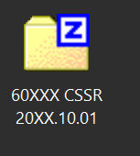

To zip (compress): right click on the main folder and select ‘Send to’, then select ‘Compressed (zipped) folder’. This will result in another folder with the same name as the main folder but with either a zipper or a ‘Z’ icon on the folder. This is the file that should be uploaded.

1. **CONGRATULATIONS!! Once the file has been uploaded, send (**[**submissions@coaemsp.org**](mailto:submissions@coaemsp.org)**) a separate email stating the program’s self-study has been submitted.**

|  |  |
| --- | --- |
| **Documents for Self-Study Report Checklist** | |
| **Standard I: Sponsorship** | |
|  | 1. Evidence of institutional accreditation (letter, certificate, website screenshot) |
|  | 1. State Office of EMS approval (official letter, email) |
|  | 1. Sample certificate of completion or diploma |
|  | 1. Articulation agreement |
|  | 1. Organizational chart of the sponsor |
|  | 1. Consortium agreement (if applicable) |
|  | 1. Notification of national accrediting agency of consortium (if applicable) |
|  | 1. Letter from CEO/President of sponsorship of consortium (if applicable) |
|  | 1. Consortium governing body meeting minutes for past 3 years (if applicable) |

|  |  |
| --- | --- |
| **Standard II: Program Goals** | |
|  | 1. Published minimum goal expectation statement (screenshot) |
|  | 1. Public Member Bio |
|  | 1. Advisory Committee meeting minutes (most recent three years) |
|  | 1. Programmatic organizational chart (program personnel and faculty, credentials, position) |
|  | 1. Corporate organizational chart for each consortium member (if applicable) |

|  |  |
| --- | --- |
| **Standard III: Resources** | |
|  | 1. Completed Resource Assessment Matrix (RAM) for the most recent three years |
|  | 1. Program Required Student Minimum Competency Numbers (approved by Medical Director and endorsed by the Advisory Committee) |
|  | 1. Syllabi for each AEMT/Paramedic core professional course (does not include general education courses or courses that are prerequisite to the Paramedic core) |
|  | 1. Personnel verification document from CoAEMSP |
|  | 1. Job descriptions for: Program Director, Medical Director, faculty (include Satellite Lead Instructor, Associate MD, and Assistant if applicable) |
|  | 1. CoAEMSP Long Range Planning form |
|  | 1. CoAEMSP Program Director Responsibilities form |
|  | 1. CoAEMSP Medical Director Review form |
|  | 1. CoAEMSP Medical Director Responsibilities form |
|  | 1. CV/resume for each full-time faculty member |
|  | 1. Clinical, field experience, and capstone field internship affiliation agreements for each affiliate, fully executed |
|  | 1. Out of State approval for affiliations (if applicable) |
|  | 1. Clinical and field experience Liaison orientation materials |
|  | 1. Capstone field internship Preceptor training materials |

|  |  |
| --- | --- |
| **Standard IV: Student and Graduate Evaluation/Assessment** | |
|  | 1. Completed CoAEMSP High Stakes Analysis form |
|  | 1. Documentation of one recent graduate: completed, graded summative, comprehensive, (final) evaluations |
|  | 1. Signed, completed sample of Terminal Competency form |
|  | 1. Summary Tracking form for most recent completed cohort |

|  |  |  |
| --- | --- | --- |
| **Standard V: Fair Practices** | | |
|  | 1. Copy of the program catalog, student handbook, and/or policies manual | |
|  | 1. Program information screenshots for: | |
|  |  | * 1. Sponsor Institutional Status |
|  |  | * 1. Program accreditation status statement (if applicable) |
|  |  | * 1. Admission policies |
|  |  | * 1. Technical standards |
|  |  | * 1. Occupational Risks |
|  |  | * 1. Advanced placement |
|  |  | * 1. Transfer of credits |
|  |  | * 1. Experiential learning |
|  |  | * 1. Credits required |
|  |  | * 1. Program costs |
|  |  | * 1. Withdrawal policy |
|  |  | * 1. Refund policy |
|  |  | * 1. Clinical Assignment Policy |
|  |  | * 1. Academic calendar |
|  |  | * 1. Student grievance |
|  |  | * 1. Appeals Process |
|  |  | * 1. Student work policy |
|  |  | * 1. Published outcomes |
|  |  | * 1. Faculty grievance |
|  |  | * 1. Faculty recruitment |
|  |  | * 1. Safeguard Policies |
|  |  | * 1. Transcript location |