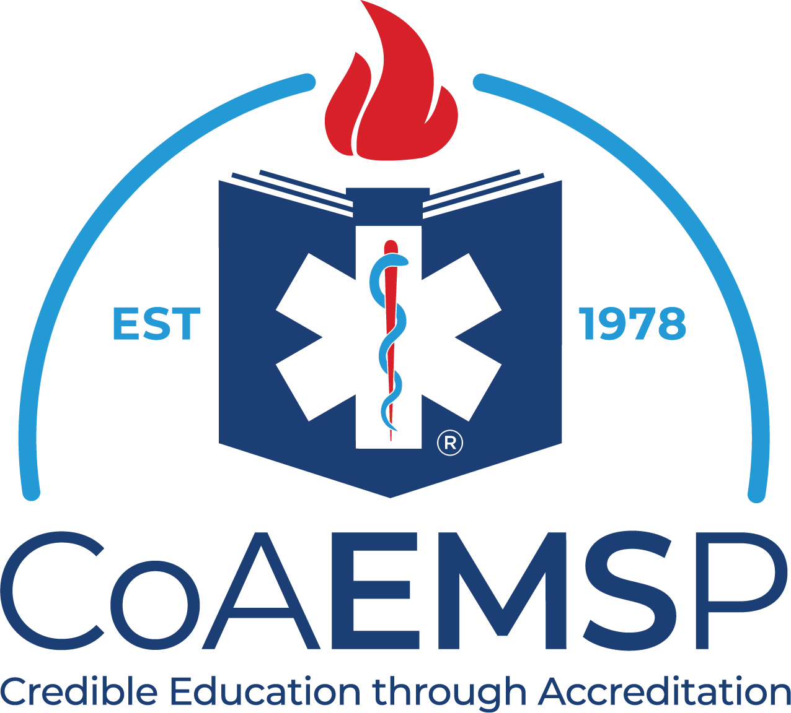

Graduation Checklist

Date: Student:

CoAEMSP Program Number: Course Number:
Program Sponsor: Course Start Date:

Level: Course Completion Date:

All the following must be verified and documented before requesting a certificate of completion for the program.

Verified | Requirement
 | Student has submitted all required paperwork
 | Minimum hour and contact requirements for program/state have been met
 | Minimum number of required patient contacts have been met and verified in a graduation report format
 | Student successfully completed the capstone cognitive examination
 | Student has successfully completed a capstone psychomotor assessment
 | A final Professional Affective Behavior Evaluation has been completed
 | Student has completed a Course Evaluation Final
 | Student has completed clinical site and preceptor evaluations
 | Student has completed a Program Resource Survey-Students
 | Program materials (resource texts) or equipment has been returned
 | Student address/email/phone is updated in system
 | Student has been instructed on NREMT and/or state licensure process
 | The Terminal Competency Form has been completed and signed by the program Medical Director
 | The Graduate Employment Verification form has been completed
 | Place of employment/placement as a Paramedic verified

Additional Campus Specific Requirements

Program Director Signature: Date:

