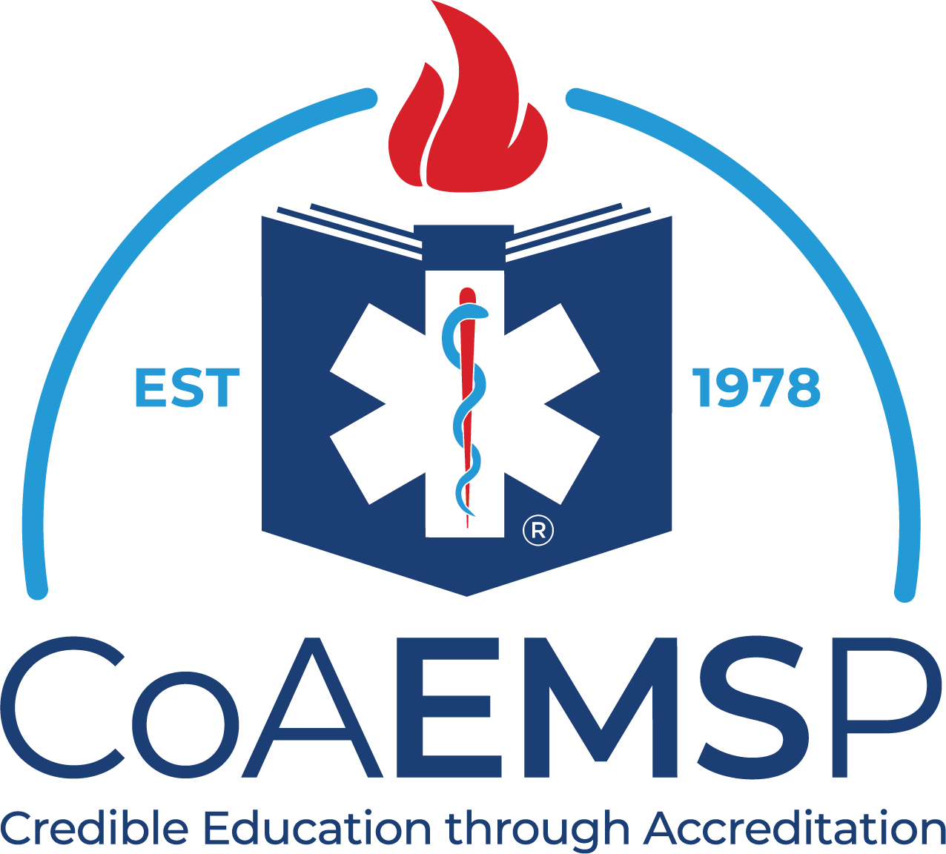

Student Academic Progress

CoAEMSP Program Number: Date:
Program Sponsor: Length in Program: months
Level: Term Number:
Student:

Category
Mid-term Average
Areas of Strength
Weakest Areas
Skills Completion
% of Skills Completed
Any Remaining Skills
Performance in Scenarios
Affective Performance
N/A
Clinical Progress
% of Clinicals Completed
Clinicals to Complete
Capstone Field Internship Progress
% of Capstone Field Internship Completed
Progress on Competencies and Contacts Completed

Student Strengths:

Areas to Improve:

Student Comments:

Program Director Signature: Date:

Other Signature: Date:

