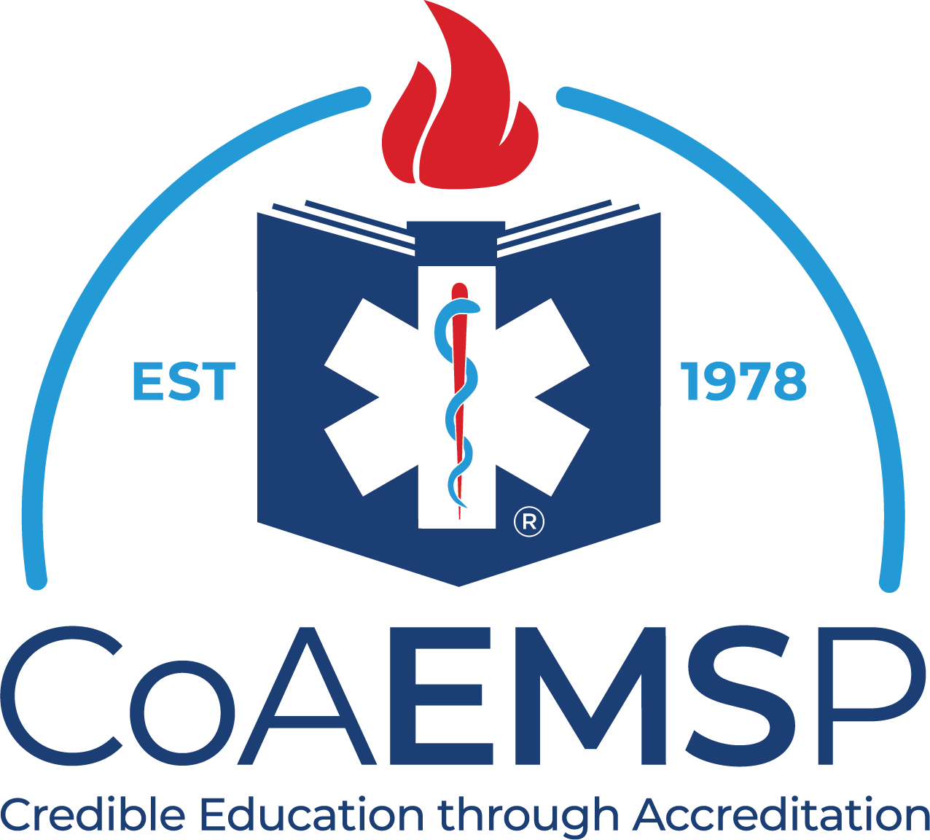

Graduate Employment Verification

CoAEMSP Program Number: Date:
Program Sponsor: Course Number:
Student: Course Start Date:
Level:
This form has been completed as part of the program closeout and included in the student file. The graduate will receive a copy with instructions to complete and return to the program director with any employment changes within 12 months following graduation.

Note: Employment placement refers only to the level selected above.
If employed on program completion
Employer
Address
Contact number/email
Supervisor
Anticipated hire date

If waiting for a position offer complete anticipated information
Employer
Address
Contact number/email
Supervisor
Anticipated hire date
No plans currently

If serving as a volunteer in lieu of a paid position
Employer
Address
Contact number/email
Supervisor
Anticipated hire date

If continuing education or military service
College name
Major
Military branch

