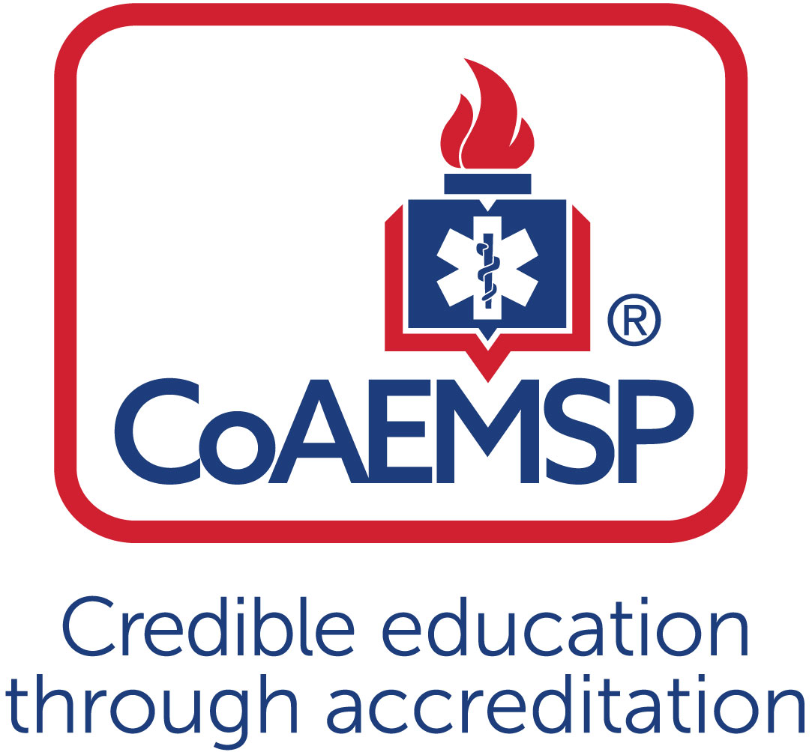
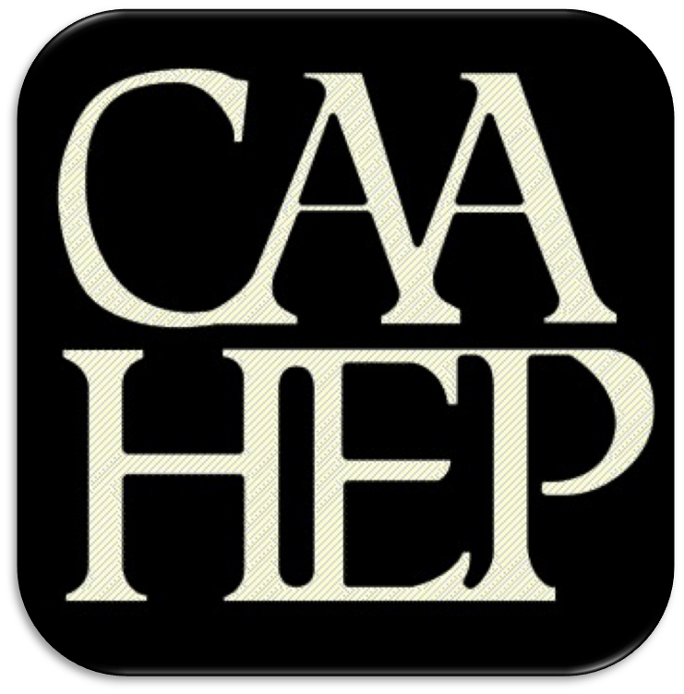

Consortium Governing Body Meeting Minutes

See last page for the purpose of the program’s Consortium.

CONSORTIUM NAME:
CoAEMSP PROGRAM NUMBER: | 600xxx | DATE, TIME, + LOCATION OF MEETING:
List all consortium members below and include program sponsor category (CAAHEP Standard I.A.1, I.A.2, I.A.3, or I.A.4):
(at least one member must meet the program sponsor requirement as described in CAAHEP Standard I.A.1-4)

Consortium Member(s) | CAAHEP Standard

ATTENDANCE

Consortium Member Institution | Representative Name | Present – Place an ‘x’ for each person present | Representative Title
 | Chair:

Agenda Item  Please Note: Do not leave columns blank, otherwise that topic  will be considered not reviewed or discussed |  | Completed/Discussed  (Yes/No) | Discussion  (include key details of the discussion) | Actions Taken
 | Call to order
 | Roll call
 | Review & approval of meeting minutes
 | Consortium agreement review & update
Consortium leadership appointments
The following appointments were voted on:
- Chair
- Vice Chair
 | Review of corporate structure & consortium member updates
 | Articulation agreement(s) [for academic credit]
Personnel update
- Review of current staffing
- Staff development activities
Program goal (the following program goal meets the 2023 CAAHEP Standard II.A. verbatim and is included in at least one of the published Paramedic program materials)
[CAAHEP Standard II.A Minimum Expectations]
- Paramedic: “To prepare Paramedics who are competent in the cognitive (knowledge), psychomotor (skills), and affective (behavior) learning domains to enter the profession.”
Program Advisory Committee updates
- Last Advisory Committee meeting date
- Meeting update
- Next Advisory Committee meeting date
Program accreditation status and updates
- Current cycle date and accreditation status
Regulatory update
- State and local regulatory authorities
 | Affiliation agreements update
Annual Report and outcome thresholds (complete dates)
- Review of data from the 202X CoAEMSP Annual Report. (most current reporting year)
- Retention
- Credentialing/NREMT
- Positive Placement
- The next Annual Report (i.e., 202X) is due May 15, 202X
Resources
- Facility update
- Capital equipment acquisitions
- Personnel resource needs
Enrollment
- 202X enrollment data (current year)
- Anticipated 202X enrollment
Assessment of effectiveness
- Measures of Paramedic program effectiveness
- Instructor and course evaluations
- Annual resource assessment of students, faculty, Medical Director, and program Advisory Committee members
- Faculty evaluations by the students completed
- Graduate and employer surveys
 | Tuition and fees update
 | Other recommendations for Paramedic program changes or enhancements
 | Other business
 | Next consortium meeting(s)
 | Adjourn

Minutes prepared by Date
Minutes approved by Date

PURPOSE OF THE CONSORTIUM AND CONSORTIUM GOVERNING BODY
A consortium is an entity consisting of two (2) or more members that exists for the purpose of operating a Paramedic educational program. The members have joined together to share resources to sponsor the Paramedic program through a written agreement which outlines the expectations and responsibilities of each of the members. A consortium must include at least one member that meets the requirement of a program sponsor as described in CAAHEP Standard I.A.1-4.

A consortium is a separate entity which must have its own decision making board (i.e., governing body or committee), a Chief Executive Officer (CEO), and must meet at least annually. A single line of responsibility from the CEO, who commonly is the Chair of this governing body or committee, to the Program Director is strongly recommended.

In all cases, the consortium must have a formal, written agreement or memorandum of understanding, which delineates governance and lines of authority. There are no requirements as to how these responsibilities need be divided; compliance is demonstrated with a thorough document that is signed by the CEO’s of each of the consortium members.

The Consortium must also have written policies and procedures to be followed by program personnel.

