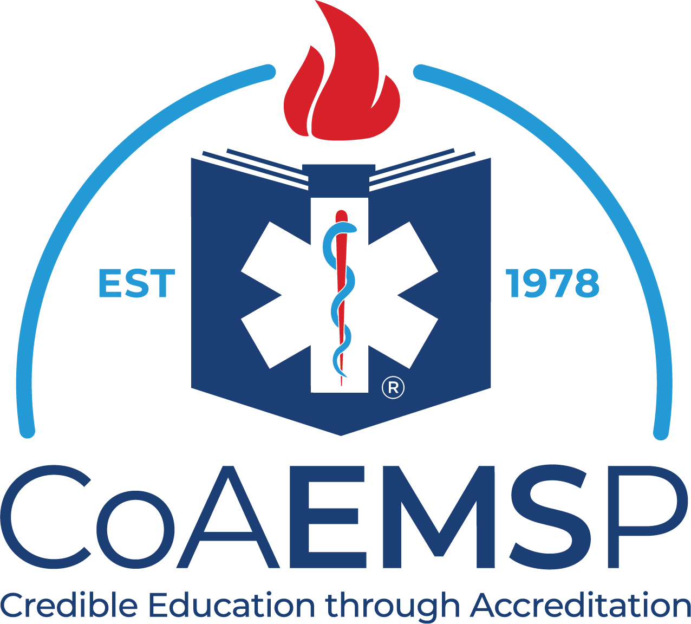

Curriculum Overview for AEMT and Paramedic
Curriculum Competencies for Educational Programs
in the Emergency Medical Services Professions

CoAEMSP Program Number:

Program Sponsor Name:

Appendix B of the 2023 CAAHEP Standards does not contain the complete outline of the competencies required to demonstrate compliance with Standard III.C. For complete information, refer to the National EMS Education Standards published by the U.S. Department of Transportation.

Content Area | Advanced EMT | Paramedic
Preparatory | Applies knowledge of the EMS system, safety/well-being of the AEMT, medical/legal and ethical issues to the provision of emergency care. | Integrates knowledge of EMS systems, the safety/well-being of the paramedic, and medical/legal and ethical issues intended to improve the health of EMS personnel, patients, and the community.
Anatomy and Physiology | Integrates knowledge of the anatomy and physiology of the airway, respiratory and circulatory systems to the practice of EMS. | Integrates knowledge of the anatomy and physiology of all human systems
Medical Terminology | Uses anatomical and medical terms and abbreviations in written and oral communication with colleagues and other health care professionals | Integrates anatomical and medical terminology and abbreviations into written and oral communication with colleagues and other health care professionals.
Pathophysiology | Applies knowledge of the pathophysiology of respiration and perfusion to patient assessment and management. | Integrates knowledge of pathophysiology of major human systems.
Life Span Development | Applies knowledge of life span development to patient assessment and management. | Integrates knowledge of life span development.
Public Health | Applies knowledge of the principles of public health epidemiology including public health emergencies, public health monitoring, health promotion and illness and injury prevention. | Applies knowledge of principles of public health and epidemiology including public health emergencies, health promotion and illness and injury prevention.
Pharmacology | Applies (to patient assessment and management) knowledge of the medications carried by AEMTs that may be administered to a patient during an emergency and chronic or maintenance medications the patient may be taking. | Integrates knowledge of pharmacology to formulate a treatment plan intended to mitigate emergencies and improve the overall health of the patient
Airway Management, Respiration and Ventilation | Applies knowledge of upper airway anatomy and physiology to patient assessment and management to assure a patent airway, adequate mechanical ventilation and respiration for patients of all ages. | Integrates knowledge of anatomy, physiology, and pathophysiology into the assessment to develop and implement a treatment plan with the goal of assuring a patent airway, adequate mechanical ventilation, and respiration for patients of all ages.
Assessment | Applies scene information and patient assessment findings (scene size up, primary and secondary assessment, patient history and reassessment) to guide emergency management. | Integrate scene and patient assessment findings with knowledge of epidemiology and pathophysiology to form a field impression. This includes developing a list of differential diagnoses through clinical reasoning to modify the assessment and formulate a treatment plan.
Medicine | Applies knowledge to provide basic and selected advanced emergency care and transportation based on assessment findings for an acutely ill patient. | Integrates assessment findings with principles of epidemiology and pathophysiology to formulate a field impression and implementation of a treatment/disposition plan for a patient with a medical complaint.
Shock and Resuscitation | Applies knowledge to provide basic and selected advanced emergency care and transportation based on assessment findings for a patient in shock, respiratory failure or arrest, cardiac failure or arrest, termination of resuscitative efforts and post resuscitation management. | Integrates knowledge of causes and pathophysiology into the management of cardiac arrest and peri-arrest states.
Trauma | Applies knowledge to provide basic and selected advanced emergency care and transportation based on assessment findings for a patient in shock, respiratory failure or arrest, cardiac failure or arrest, termination of resuscitative efforts and post resuscitation management. | Integrates knowledge of causes and pathophysiology into the management of cardiac arrest and peri-arrest states.
Special Patient Populations | Applies knowledge of growth, development and aging and assessment findings to provide basic and selected advanced emergency care and transportation for a patient with special needs. | Integrates assessment findings with principles of pathophysiology and knowledge of psychosocial needs to formulate a field impression and implement a treatment/disposition plan for patients with special needs.
EMS Operations | Knowledge of operational roles and responsibilities to ensure patient, public and personnel safety. | Knowledge of operational roles and responsibilities to ensure patient, public and personnel safety.
Clinical Behavior/Judgement
Assessment | Perform a basic history and physical examination to identify acute complaints and monitor changes.  Formulate a field diagnosis based upon an actual and/or potential illness or injury. | Perform a comprehensive history and physical examination to identify factors affecting the health and health needs of a patient.  Relate assessment findings to underlying pathological and physiological changes in the patient’s condition.  Integrate and synthesize the multiple determinants of health and clinical care.  Formulate a field diagnosis based on an analysis of comprehensive assessment findings, anatomy, physiology, pathophysiology, and epidemiology.  Perform health screening and referrals.
Therapeutic Communication and Cultural Humility | Effectively communicates in a non- discriminatory manner that addresses inherent or unconscious bias, is culturally aware and sensitive, and intended to improve patient outcome. | Effectively communicates in a non-discriminatory manner that addresses inherent or unconscious bias, is culturally aware and sensitive, and intended to improve patient outcome.
Psychomotor Skills | Safely and effectively perform all psychomotor skills within the National EMS Scope of Practice Model and state  Scope of Practice at this level. | Safely and effectively perform all psychomotor skills within the National EMS Scope of Practice Model and state Scope of Practice at this level.
Professionalism | Demonstrate professional affective domain behaviors including but not limited to:  - Integrity Empathy/compassion Self-motivation  - Appearance/personal hygiene Communications  - Time management Teamwork/diplomacy Respect  - Patient advocacy  - Careful delivery of service Lifelong learning | Is a role model of exemplary professional affective domain behaviors including but not limited to:  - Integrity  - Empathy/compassion Self-motivation  - Appearance/personal hygiene Communications  - Time management Teamwork/diplomacy Respect  - Patient advocacy  - Careful delivery of service Lifelong learning
Decision Making | Initiates interventions based on assessment findings intended to provide symptom relief (within the provider’s scope of practice) while providing access to definitive care.  Evaluates the effectiveness of interventions and modifies treatment plan accordingly. | Performs interventions as part of a treatment plan intended to provide symptom relief and improve the overall health of the patient.  Evaluates the effectiveness of interventions and modifies treatment plan accordingly.  Evaluates decision making strategy for cognitive errors to enhance future critical thinking skills (metacognition)
Record Keeping | Report and document assessment findings, interventions performed, and clinical decision making. | Report and document assessment findings, interventions performed, and clinical decision making.
Team Dynamics | The entry-level clinician serves as a team member, while gaining the experience necessary to function as the team leader. | The entry-level clinician serves as a team member, while gaining the experience necessary to function as the team leader.
Safety | Ensure the safety of the rescuer, other public safety personnel, civilians, and the patient. | Ensure the safety of the rescuer, other public safety personnel, civilians, and the patient.

Date reviewed with the program’s Advisory Committee:

Program Director Signature: Date:

Medical Director Signature: Date:

