Step By Step Instructions
Addendum to the Self-Study Report

The self-study templates (i.e., ISSR or CSSR) have recently gone through extensive revisions. This Self-Study Addendum was created to help the CoAEMSP collect some additional items as evidence rather than require programs to complete the entire revised self-study report.

Please be sure all the documentation is positioned so that it does not need to be rotated to view and the ability to rename a folder and/or document is not restricted.

Please use the steps on the following pages as a guide in completing the addendum to the self-study reports.

Double-click on the PDF icon below to access the Directions for Creating a Single PDF Document.

For questions or help composing the Self-Study Addendum, please contact Lisa Collard (lisa@coaemsp.org or ext. 118)

- Create a main folder on your desktop titled with the Program #, SSR Addendum [i.e., ISSR, CSSR], and Submission Due Date [yyyy.mm.dd].
(e.g., 600XXX CSSR Addendum 20XX.09.01).

- Open the main folder and create one sub-folder for the requested documentation titled Addendum.

- Save the Self-Study Addendum (Word document)sent to you via email to the main folder you created on the desktop.

- Name the Self-Study Addendum the same as the main folder Program #, SSR Addendum [i.e., ISSR, CSSR], and Submission Due Date [yyyy.mm.dd]. (e.g., 600XXX CSSR Addendum 20XX.09.01).

The main folder should look like the example below after completing Steps 1-4 above.

Single sub-folder
Renamed Word Template
Main folder

- The Self-Study Addendum lists nine (9) CAAHEP Standards outlined in green. Each Standard requires specific documentation to be submitted which is identified in italic font below each of the green Standard sections. The blue box directly below the required documentation in italic outlines where the documentation should be placed and the type of acceptable file format(s).

Begin by compiling the specific documentation required for the first item in the green Standard section which is Standard III.B. – Resources Personnel. Once the documentation is ready, place it in the Addendum sub-folder and name the document using the hyperlink title listed in the orange box. Create a hyperlink to the documentation by highlighting the words in the orange box (e.g., 01 Personnel), right click, select ‘hyperlink’, and locate the specific file in the Addendum sub-folder (see pictures on the next page).

Hyperlink in the Self-Study Addendum template and documentation in the Addendum sub-folder title

- Continue to the second green Standard section (i.e., Standard III.B.1.a.1 thru 7) which requires three (3) specific items of documentation. Complete the same steps in creating the hyperlink to each of the specific documentation files. Then continue to the remaining green Standard sections and do the same until all nine (9) green Standard sections have been completed.
Please Note: Each hyperlink is only able to be created for one document. Therefore, if there are multiple documents provided for the response, then the documentation must be included as a single PDF file. See the instructions for creating a single PDF document on the cover page of these instructions if needed.

- Once all the Standard sections have been completed, the Addendum sub-folder should look like the following picture.

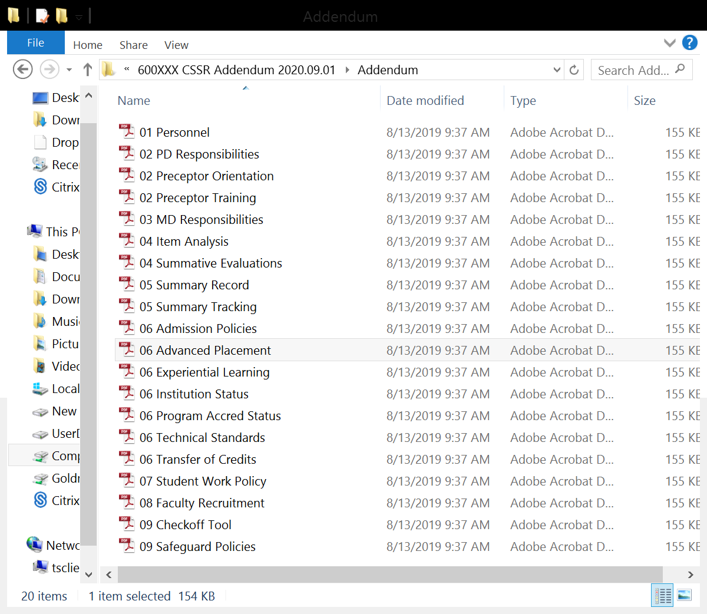

- Return to the Self-Study Addendum and verify each hyperlink works for each of the required items of documentation in the Addendum sub-folder. Please contact Lisa Collard (lisa@coaemsp.org or 214-703-8445 ext. 118) at the CoAEMSP with any questions regarding linking.

- Once all the links open properly, the self-study is ready to be submitted. Zip (compress) the entire main folder. Upload the zipped (compressed) folder to the sponsor’s fileshare account no later than the due date which was provided in the CoAEMSP Self-Study Addendum email.
Please Note: Zipped files may look a little different depending on the version being used to zip (compress) the files.

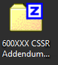
To zip (compress): right click on the main folder and select ‘Send to’, then select ‘Compressed (zipped) folder’. This will result in another folder with the same name as the main folder but with either a zipper or a ‘Z’ icon on the folder. This is the file that should be uploaded.

- CONGRATULATIONS!! Once the file has been uploaded, send an email to submissions@coaemsp.org to notify the CoAEMSP the Self-Study Addendum has been submitted.

