Step-By-Step Instructions

The Program’s Response to the Site Visit Findings Letter/Progress Report template is an Excel document. There is a preset link for each area of non-compliance requiring further evidence to address that particular Standard. The preset link will only work if the evidence is named exactly as listed and the type of file format is an Adobe Portable Document (PDF). If the preset link does not work, you will need to manually link the documentation. It is very important that the evidence requested for each area of non-compliance within the Site Visit Findings Letter/Progress Report template matches the evidence provided for each area of non-compliance in the Evidence folder.

Please be sure the scanned documentation is positioned so that they do not need to be rotated to view and the ability to rename the folder and/or documents is not restricted.

Please use the steps on the following pages as a guide in completing the program’s response to the Findings Letter/Progress Report.

Double-click on the PDF icon below to access the Directions for Creating a Single PDF Document.

***Remember to save your work once you completed the Excel template***

For questions or help composing the program’s response, please contact Lisa Collard (lisa@coaemsp.org or ext. 118)

For submission of a completed program’s response, send electronically via email to (submissions@coaemsp.org).

- Create a main folder on your desktop titled with the Program #, Sponsor Name Response, Response Due Date [yyyy.mm.dd] (e.g., Paramedic: 600XXX ABC College Response 20XX.06.01 or AEMT: 15XXXX ABC College Response 20XX.06.01).

- Open the main folder and create one sub-folder for the requested documentation titled Evidence.

- Save the Response to the Findings Letter/Progress Report Excel template sent to you via email in the main folder you created on the desktop.

- Rename the Program’s Response to the Findings Letter/Progress Report Excel template the same as the main folder Program #, Sponsor Name Response, Response Due Date [yyyy.mm.dd] (e.g., Paramedic: 600XXX ABC College Response 20XX.06.01 or AEMT: 15XXXX ABC College Response 20XX.06.01).

The main folder should look like the example below after completing Steps 1-4 above.

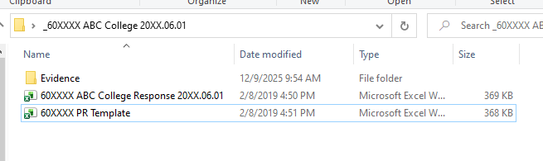
Main folder
Renamed Excel Template
Single sub-folder

- Open the Program’s Response to the Findings Letter/Progress Report Excel template and complete the green highlighted cells in the top section of the Excel template (rows 9, 11, and 13).

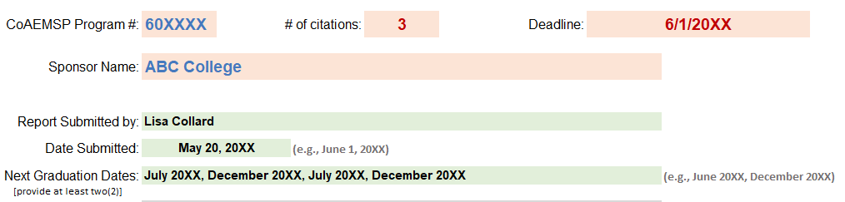
Green highlighted rows 9, 11, & 13

- Scroll down to the ‘Finding 1’ section (rows 21-32) and gather the requested evidence as outlined in the italic text.
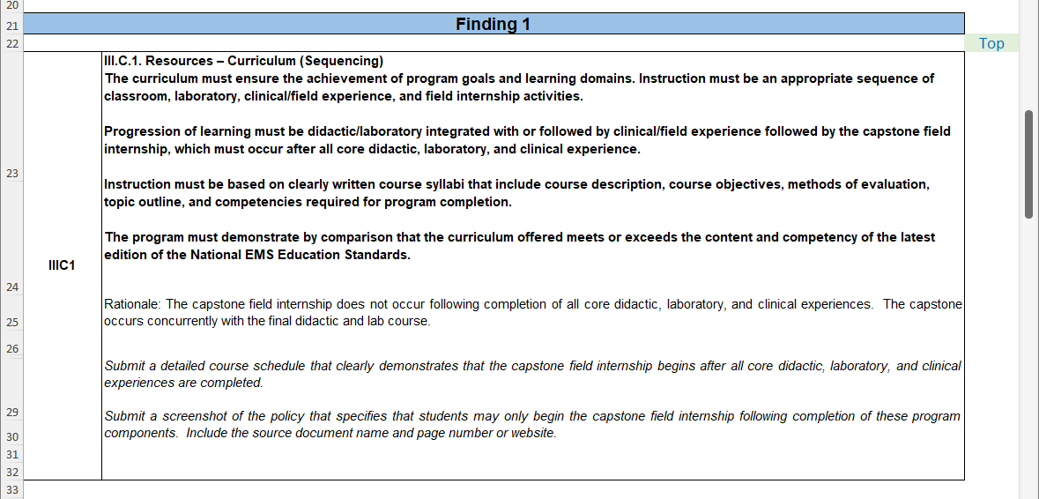
Requested Evidence

- Scan all requested evidence/documentation for ‘Finding 1’ as a single PDF document in the Evidence sub-folder. The evidence for this area of non-compliance has been preset to automatically link. In order for the automatic link to work, the scanned documentation MUST be titled with the 'EXACT document name' and the type of file format MUST be an Adobe Portable Document (PDF) as directed in the orange section (row 36-37) below the ‘Finding 1’ section of the Excel template. Please Note: Directions for Creating a Single PDF Document can be accessed on page 1 of these instructions by double-clicking on the PDF icon in green.

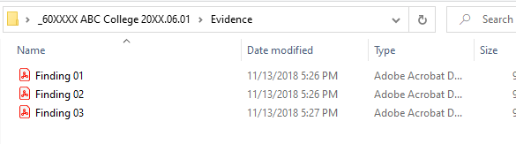
Evidence sub-folder with documentation for Finding 01.

- Test the link in the Excel template once the documentation has been placed in the Evidence sub-folder. Please Note: If this is not named exactly as directed and in a PDF format, then the automatic link will not work. Any Findings Letter/Progress Report responses that have not been properly linked will NOT be accepted by the CoAEMSP and returned to the program until the documentation has been properly linked.
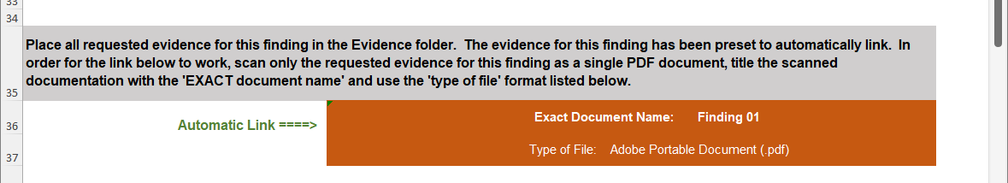

- If the automatic link works, then skip to step 11. If the automatic link does not work and the evidence/documentation has been named correctly and the type of file format is an Adobe Portable Document (PDF), then the automatic link pathway may be leading to a temporary location and it will need to be redirected. Follow step 10 to redirect the link.
Hover cursor over link
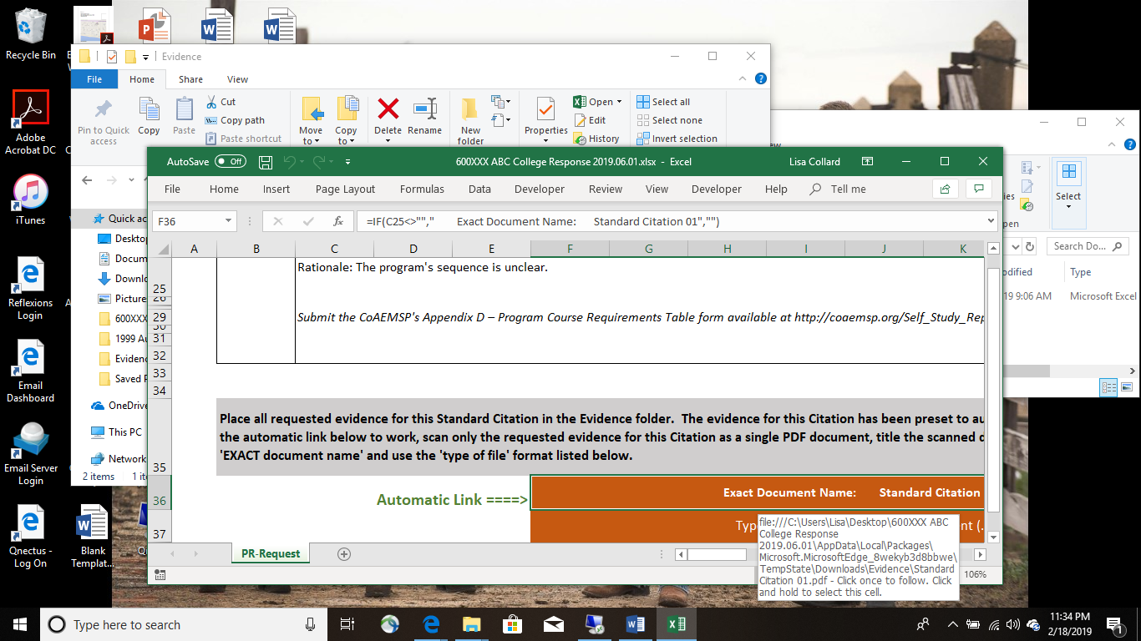
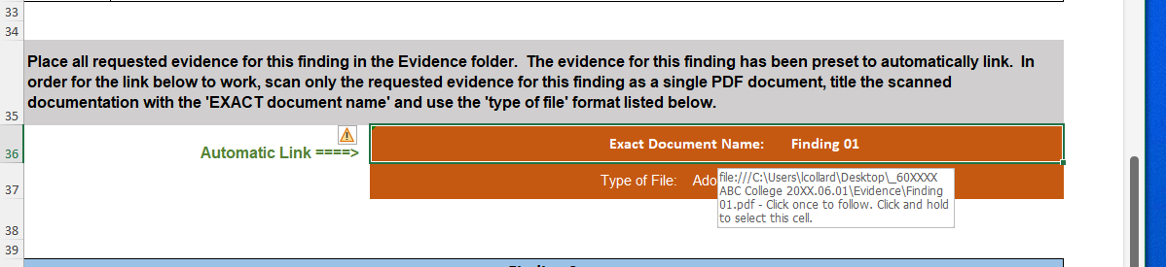
Correct Link Pathway
Incorrect Link Pathway
(this one identifies a temporary link)

- Place the cursor over the Finding 01 link within the Response to the Findings Letter/Progress Report Excel template, right click and select edit hyperlink, locate and select the Finding 01 evidence within your Evidence sub-folder. This will need to be done for each Finding being addressed. If the link does not work, then contact Lisa Collard (lisa@coaemsp.org or ext. 118) at the CoAEMSP.

- For additional areas of non-compliance, scroll down to the next Finding section (e.g., Finding 02, Finding 03, etc.), gather the requested evidence as outlined in the italic text, and scan all requested evidence/documentation for each area of non-compliance/finding as a single PDF document in the Evidence sub-folder as directed in the orange section(s) below each appropriate Finding section. Please Note: Double check to make sure each automatic link works for every Finding listed. If not, follow step 10.
The Evidence sub-folder should look like the example below if the program has twenty-five (25) Findings.

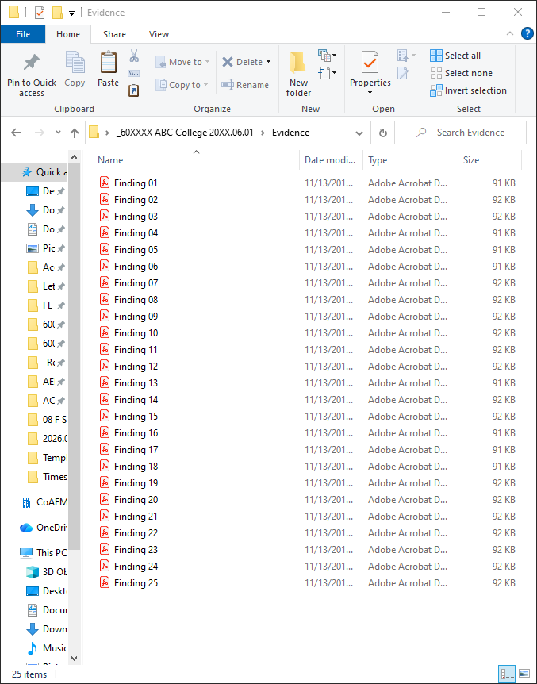

- Once the requested evidence for each area of non-compliance has been reviewed and included in the ‘Evidence’ sub-folder, zip (compress) the entire main folder, and send it electronically (email it) to submissions@coaemsp.org no later than the due date indicated in the CAAHEP/CoAEMSP official letter. Please Note: The links will no longer work once the documentation has been zipped and zipped files may look a little different depending on the version of Word being used.

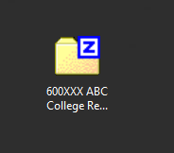
- CONGRATULATIONS!! You should have completed and submitted all the requested items for the program’s response to the CoAEMSP.

Please Note: Program Responses to the Findings Letter will be reviewed at the CoAEMSP meeting identified in the Site Visit Findings Letter. Once CoAEMSP reviews the response, then a recommendation will be sent to CAAHEP for their next scheduled meeting. The program will not receive a letter based on CoAEMSP’s recommendation. CAAHEP will send official notification of their decision to the program within a week or so after the close of the CAAHEP meeting.

Program Responses to the Progress Report will be reviewed at next scheduled CoAEMSP meeting. The program will receive a CoAEMSP letter approximately thirty (30) days after the close of the CoAEMSP meeting.

