Step By Step Instructions
Documents for the Site Visit

These instructions were created to help programs provide the CoAEMSP with additional documentation in order to bridge the time frame from submission of the Self-Study report to the site visit. The specified documents are only required when they provide updated information, such as Advisory Committee minutes. Do not upload any documents provided in the program’s self-study submission.

Please be sure the documentation is positioned so that it does not need to be rotated to view and the ability to rename a folder and/or document is not restricted.

Please use the steps on the following pages as a guide in completing the documents for the site visit.

Double-click on the PDF icon below to access the Directions for Creating a Single PDF Document.

For questions or help composing the Documents for the Site Visit, please contact Lisa Collard (lisa@coaemsp.org or ext. 118)

The program’s designated Sharefile folder is available when the program receives the official site visit confirmation email. Please use the link below to access the login page.
https://coaemsp.sharefile.com/Authentication/login

Please Note: Username => Program Director (PD) email
Password => Established by the PD the 1sttime the PD logged in.
If you do not remember the password, please follow the ‘Forgot Password’ process on the Sharefile’s login page.

- Once the site visit has been scheduled, the program is sent the official site visit confirmation email approximately 6-8 weeks prior to the first day of the site visit. This email contains the date of the site visit, site visit team contact information, whether the visit will be virtual or in-person, if there are any First Day of Site Visit (FSV) items due, a suggested site visit agenda, a list of documents to assist the program with coordinating the site visit, as well as, other important information regarding the site visit.

- Programs are required to complete the Documents for the Site Visit form which provides the program with the opportunity to identify changes that have taken place since the submission of the program's Self Study Report and issuance of the executive analysis. This form is located on the Site Visits page of the CoAEMSP website at www.coaemsp.org. Please Note: Complete the form and gather all the supporting documentation prior to uploading anything to the Sharefile folder.

- Programs are required to complete the Response to Executive Analysis (EA) Program Update form which provides the program with the opportunity to identify changes that have taken place since issuance of the EA. This form is located on the Site Visits page of the CoAEMSP website at www.coaemsp.org. Please Note: Complete the form and gather all the supporting documentation prior to uploading anything to the Sharefile folder.

- A completed Documents for the Site Visit form and a completed Response to Executive Analysis (EA) Program Update form along with any supporting documentation, as applicable, are required to be uploaded to the appropriate sub-folders within the program’s designated Sharefile folder no later than two (2) weeks prior to the site visit.

The Sharefile folder should look like the example below.

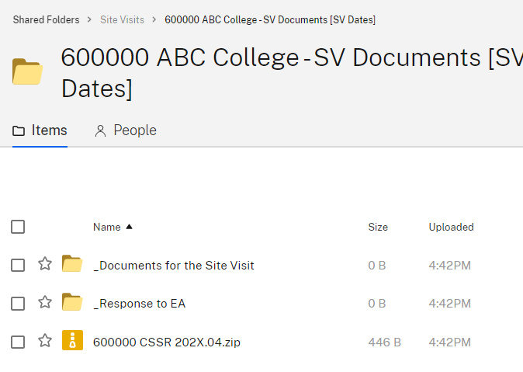
The completed forms along with any supporting documentation (if applicable) will be uploaded to the respective sub-folders
Program’s Self-Study Report and supporting documentation
Main folder

- There are eight (8) areas (i.e., Minutes, Manuals, Summary Tracking, etc.) outlined in green on the Documents for the Site Visit form. A question within each area must be answered. If the answer to the question is ‘Yes’, then specific supporting documentation is required for that area. The orange box next to each question outlines an example for how the documentation should be named.

If the answer to the question is ‘No’, then no documentation is required and you can proceed to the next question.

For example, for the first area in green which is Minutes. If there have been any meetings (i.e., Advisory Committee, consortium governing body, faculty, etc.) since the Self-Study Report was submitted, ‘Yes’ would be selected for the first question and the meeting minutes would be named using the naming convention outlined on the form and provided as supporting documentation. If there were two advisory committee meeting minutes and a consortium governing body meeting minutes as shown in the example on the form, then that supporting documentation would be placed in the _Documents for the Site Visit sub-folder. (see _Documents for the Site Visit sub-folder picture below).
_Documents for the Site Visit sub-folder
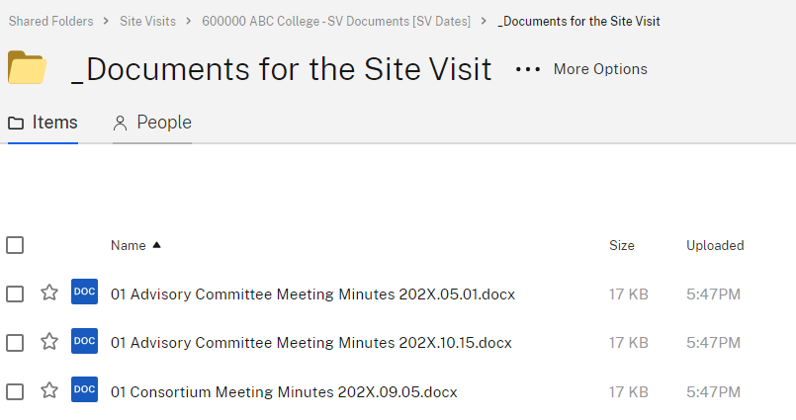
Supporting documentation for the Minutes area

- Continue to the second green area on the Documents for the Site Visit form. Complete each of the questions and provided specific documentation for the questions answered ‘Yes’ until all eight (8) green areas have been completed.
Please Note: Do not provide any documents previously submitted.

- Once the Documents for the Site Visit form is completed, all eight (8) questions have been answered, and the supporting documentation has been uploaded to the _Documents for the Site Visit sub-folder in Sharefile, the sub-folder should look like the picture below.
Please Note: If you have more supporting documents than shown, then the _Documents for the Site Visit sub-folder on Sharefile will have more files included. If some questions were answered ‘No’, then the _Documents for the Site Visit sub-folder on Sharefile will not have supporting documentation for those areas.

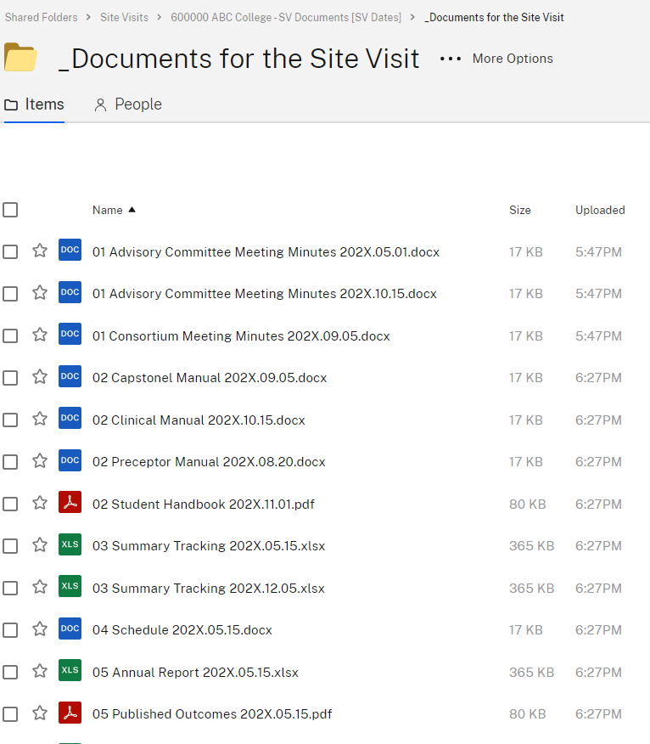
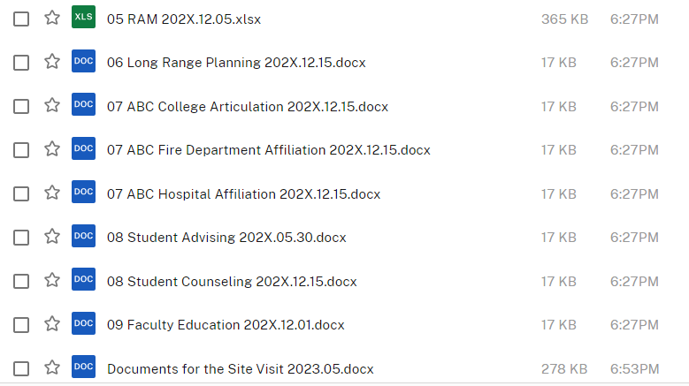
Remember to include the Documents form in the sub-folder

- CONGRATULATIONS!! Once the Documents for the Site Visit form, Response to the Executive Analysis Program Update form, and all supporting documentation has been uploaded to the respective Sharefile folders, send an email to the site visit team to notify them the additional site visit documentation has been submitted.

