Step-By-Step Instructions

The Program’s Response to the Site Visit Findings Letter/Progress Report template is an Excel document (software version 2013). There is a preset automatic link for each Standard Citation requiring further evidence to address that particular Standard. The preset automatic link will only work if the evidence is named exactly as listed and the type of file format is an Adobe Portable Document (PDF). You will not be able to manually link the documentation, so it is very important that the evidence requested for each Standard Citation within the Site Visit Findings Letter/Progress Report template matches the evidence provided for each Standard Citation in the Evidence folder.

Please be sure the scanned documentation is positioned so that they do not need to be rotated to view and the ability to rename the folder and/or documents is not restricted.

Please use the steps on the following pages as a guide in completing the program’s response to the Findings Letter/Progress Report.

Double-click on the PDF icon below to access the Directions for Creating a Single PDF Document.

***Remember to save your work once you completed the Excel template***

For questions or help composing the program’s response, please contact Lisa Collard (lisa@coaemsp.org or ext. 118)

For submission of a completed program’s response, send electronically via email to (submissions@coaemsp.org).

- Create a main folder on your desktop titled with the Program #, Sponsor Name Response, Response Due Date [yyyy.mm.dd] (e.g., 600XXX ABC College Response 2019.06.01).

- Open the main folder and create one sub-folder for the requested documentation titled Evidence.

- Save the Response to the Findings Letter/Progress Report Excel template sent to you via email in the main folder you created on the desktop.

- Rename the Program’s Response to the Findings Letter/Progress Report Excel template the same as the main folder Program #, Sponsor Name Response, Response Due Date [yyyy.mm.dd] (e.g., 600XXX ABC College Response 2019.06.01).

The main folder should look like the example below after completing Steps 1-4 above.
Single sub-folder
Main folder
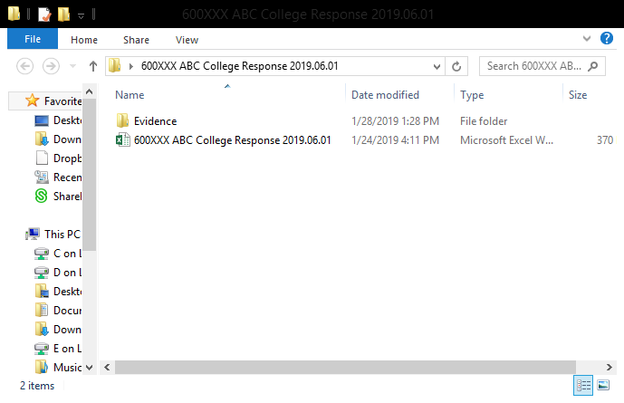
Renamed Excel Template

- Open the Program’s Response to the Findings Letter/Progress Report Excel template and complete the green highlighted cells in the top section of the Excel template (rows 9, 11, and 13).
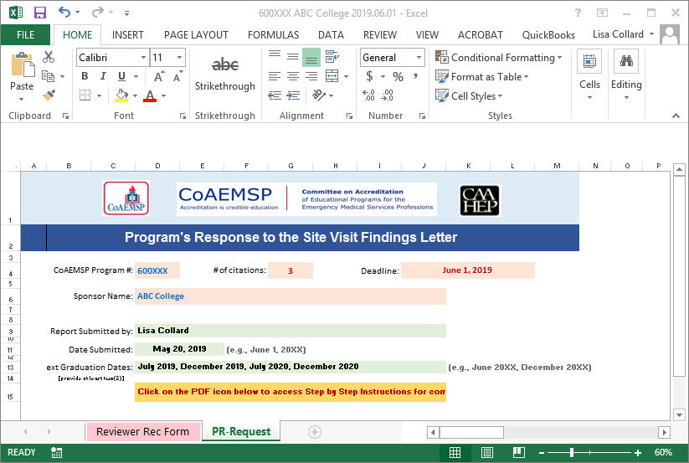

Green highlighted rows 9, 11, & 13

- Scroll down to the ‘Standard Citation 1’ section (rows 21-32) and gather the requested evidence as outlined in the italic text.

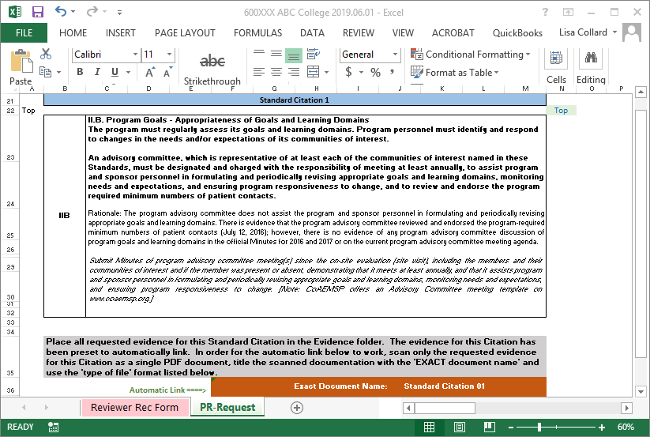
Requested Evidence

- Scan all requested evidence/documentation for the ‘Standard Citation 01’ as a single PDF document in the Evidence sub-folder. The evidence for this Citation has been preset to automatically link. In order for the automatic link to work, the scanned documentation MUST be titled with the 'EXACT document name' and the type of file format MUST be an Adobe Portable Document (PDF) as directed in the orange section (row 36-37) below the ‘Standard Citation 01’ section of the Excel template. Please Note: Directions for Creating a Single PDF Document can be accessed on page 1 of these instructions by double-clicking on the PDF icon in green.

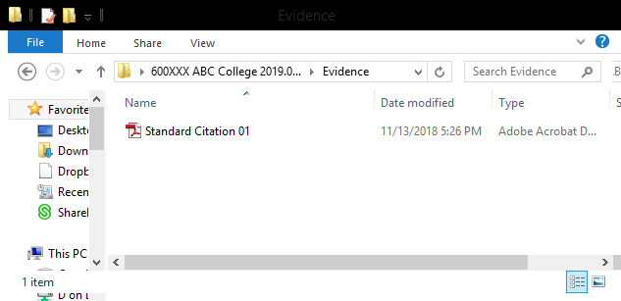
Evidence sub-folder with documentation for Standard Citation 01.

- Test the link in the Excel template once the documentation has been placed in the Evidence sub-folder. Please Note: If this is not named exactly as directed and in a PDF format, then the automatic link will not work. Any Findings Letter/Progress Report responses that have not been properly linked will NOT be accepted by the CoAEMSP and returned to the program until the documentation has been properly linked.
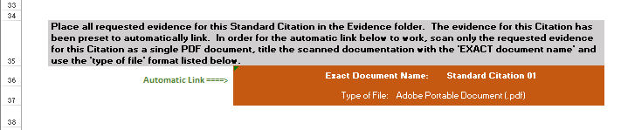

- If the automatic link works, then skip to step 11. If the automatic link does not work and the evidence/documentation has been named correctly and the type of file format is an Adobe Portable Document (PDF), then the automatic link pathway may be leading to a temporary location and it will need to be redirected. Follow step 10 to redirect the link.
Hover cursor over link
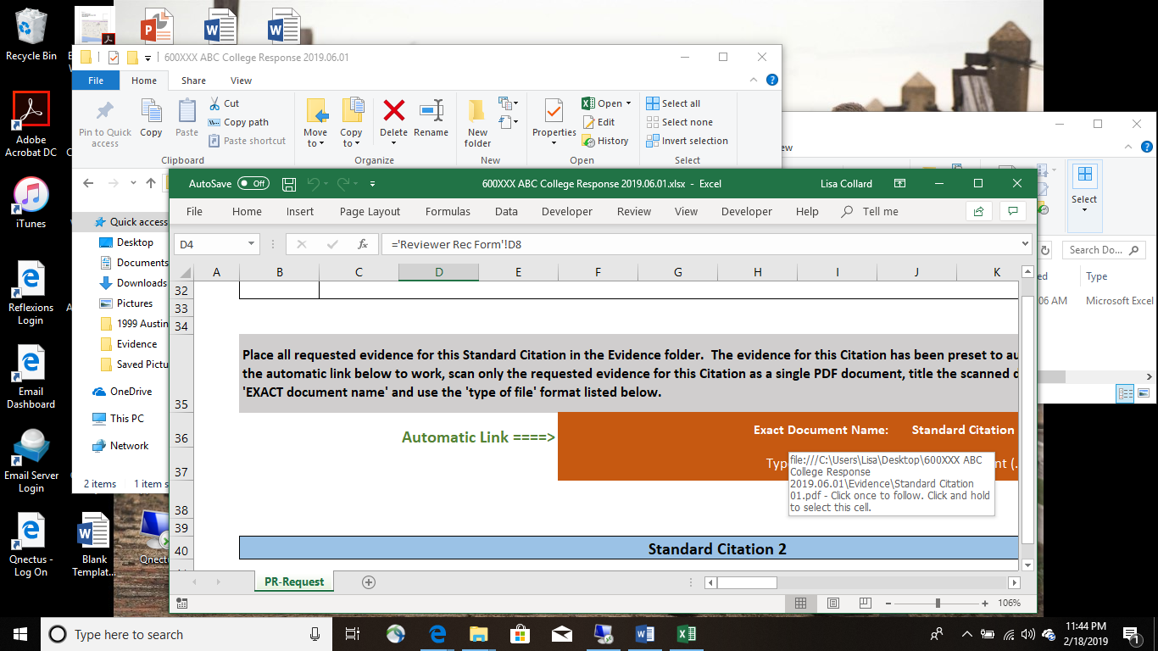
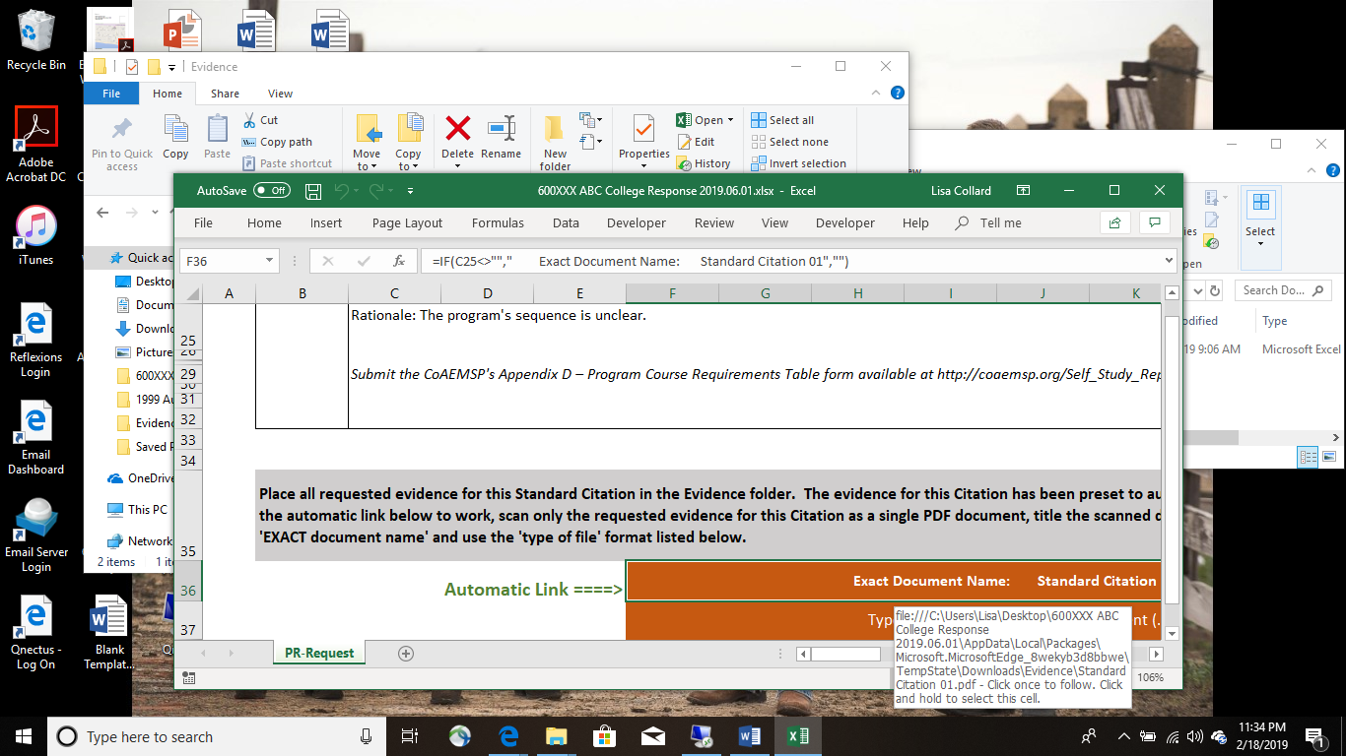
Correct Link Pathway
Incorrect Link Pathway

- Place the cursor over the Standard Citation 01 link within the Response to the Findings Letter/Progress Report Excel template, right click and select edit hyperlink, locate and select the Standard Citation 01 evidence within your Evidence folder. This will need to be done for each Standard Citation being addressed. If the link does not work, then contact Lisa Collard (lisa@coaemsp.org or ext. 118) at the CoAEMSP.

- For additional Standard Citations, scroll down to the next Citation section (e.g., Standard Citation 02, Standard Citation 03, etc.), gather the requested evidence as outlined in the italic text, and scan all requested evidence/documentation for each Standard Citation as a single PDF document in the Evidence sub-folder as directed in the orange section(s) below each appropriate Citation section. Please Note: Double check to make sure each automatic link works for every Standard Citation listed. If not, follow step 10.
The Evidence sub-folder should look like the example below if the program has twenty-five (25) Standard Citations.

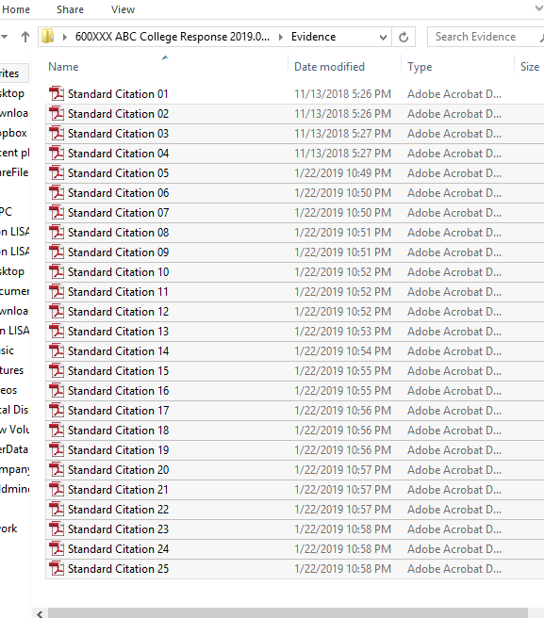

- Once the requested evidence for each Standard Citation has been reviewed and included in the ‘Evidence’ sub-folder, zip (compress) the entire main folder, and send it electronically (email it) to submissions@coaemsp.org no later than the due date indicated in the CAAHEP/CoAEMSP official letter. Please Note: Zipped files may look a little different depending on the version of Word being used.

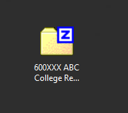
- CONGRATULATIONS!! You should have completed and submitted all the requested items for the program’s response to the CoAEMSP.

Please Note: Program Responses to the Findings Letter will be reviewed at the CoAEMSP meeting identified in the Site Visit Findings Letter. Once CoAEMSP reviews the response, then a recommendation will be sent to CAAHEP for their next scheduled meeting. The program will not receive a letter based on the CoAEMSP’s recommendation. CAAHEP will send official notification of their decision to the program within a week or so after the close of the CAAHEP meeting.

Program Responses to the Progress Report will be reviewed at next scheduled CoAEMSP meeting. The program will receive a CoAEMSP letter approximately thirty (30) days after the close of the CoAEMSP meeting.

