Step-By-Step Instructions
Letter of Review (LoR) Application

The LoR Application is an Excel document (software version 2013). The required documentation must be named exactly as listed and in the specified file format. However, most of the documents will require the file format to be an Adobe Acrobat Document (PDF). If the documentation is not named exactly as directed and in the correct file format, then the LoR Application will be returned and the program must fix the naming/formatting issues identified before the CoAEMSP will accept it.

Cloud-based services (i.e., SharePoint, Google Docs, etc.) must not be used when completing the LoR Application. This type of software tends to remove the built-in formulas from Excel.

Please be sure the documentation is positioned so that it does not need rotating to view and the ability to rename a folder and/or document is not restricted.

Throughout the LoR Application, if the CoAEMSP has a form available for sponsors to use, the following purple note will identify there is a form and the name of the form is displayed with a link to the form location on the right.
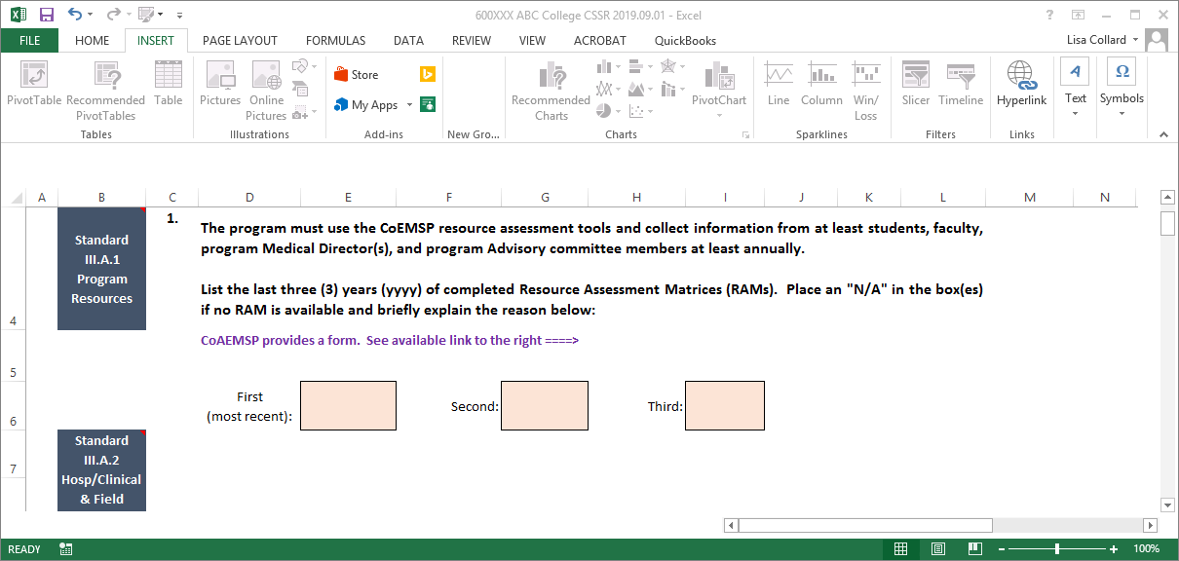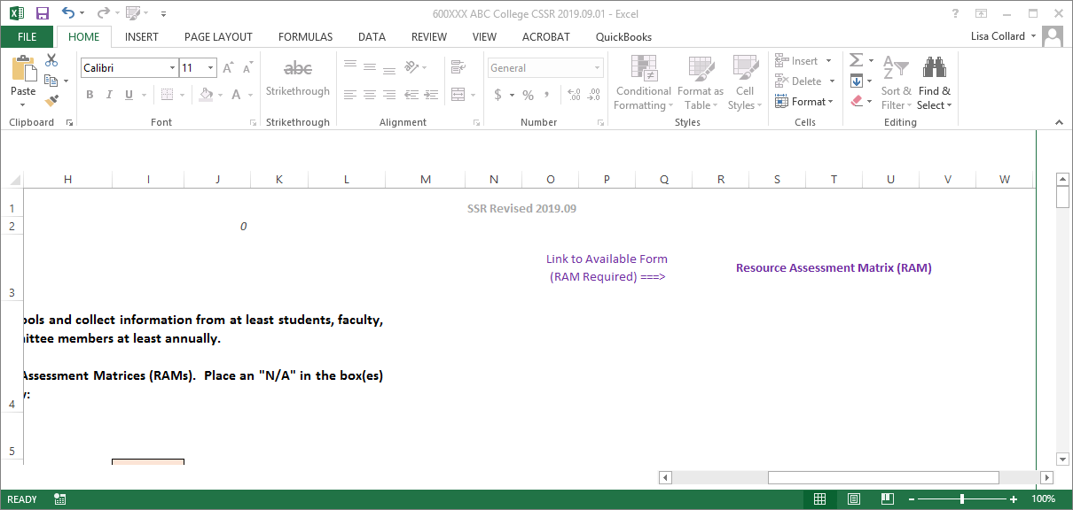

Please use the steps on the following pages as a guide in completing the application along with the documents checklist located at the end of these instructions.

Left click on the PDF icon below so it is outlined (highlighted), then double-click on it to access the Directions for Creating a Single PDF Document.

***Remember to save your work often as you complete the Excel template***

For questions or help composing the application, please contact Lisa Collard (lisa@coaemsp.org or 214-703-8445 ext. 118)

- Save the Letter of Review (LoR) Application Invoice Request form located on the CoAEMSP website to your desktop, then complete and submit the form to the CoAEMSP as directed. Once the form is submitted, the CoAEMSP will issue the program an invoice which will be due upon submission of the LoR Application. This invoice number (e.g., 5-digit # LoR) is required in order to appropriately title the LoR Application.

- Save the LoR Application located on the CoAEMSP website to your desktop.

- Create a main folder on your desktop and title it with the invoice number issued by the CoAEMSP (e.g., 5-digit # LoR), App, and date of intended submission [yyyy.mm.dd]. (e.g., 20033LoR App 20XX.05.14).

- Open the main folder and create one sub-folder for the requested documentation titled Application.

- Title the application using the same name as the main folder with the CoAEMSP invoice number (e.g., 5-digit # LoR), App, and intended submission date [yyyy.mm.dd]. (e.g., 20033LoR App 20XX.05.14).

The main folder should look like the example below after completing Steps 1-5 above.
Main folder
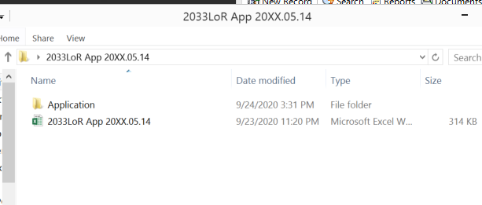
Renamed Excel Template
Single sub-folder

- Open the application and begin by completing all light orange text boxes on the Title Page and Program Info tabs. All blue text boxes will automatically populate data once the associated tab has been completed. Data cannot be placed directly into the blue text boxes. Please Note: Cloud-based services (i.e., SharePoint, Google Docs, etc.) must not be used when completing the application or self-study template. This type of software tends to remove the built-in formulas from Excel.

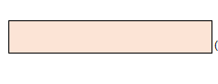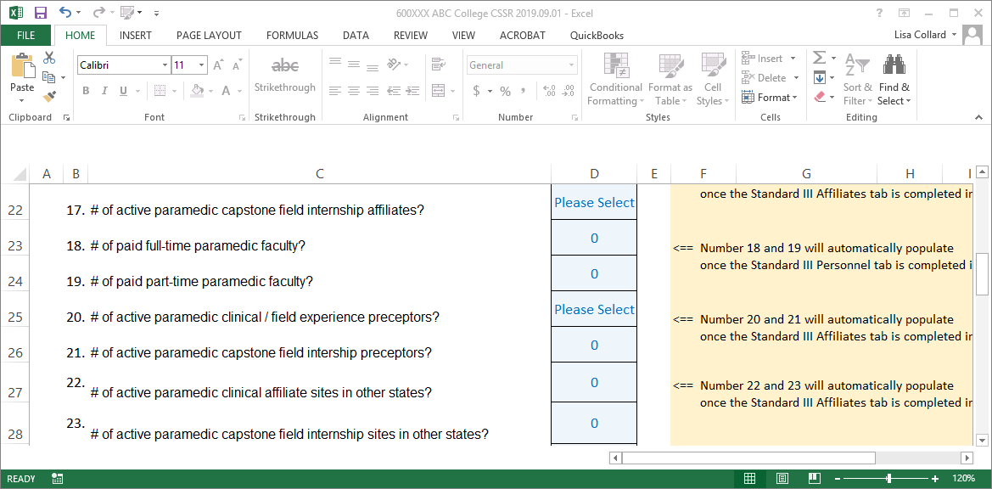
Blue Text Boxes
Light Orange Text Box

- Continue to the Standard I-Sponsorship and Standard III-Personnel tabs and complete the light orange text boxes. Please keep in mind, the application has built in logic and some questions may appear to be incomplete (e.g., Standard I question 3). However, the question will populate based on how the sponsor answers previous questions (e.g., questions 1 and 2) so it is important to complete the tabs in order rather than skipping around. The blue box directly above the dark orange section identifies the documentation needed and the dark orange section identifies the specific name and format required to be used when including the file in the Application sub-folder. The required documentation MUST be titled with the 'EXACT document name' and the type of file format that MUST be used (see picture below). Please Note: If the documentation is not named exactly as directed and in the correct file format, then the application will be returned and the program must fix the naming/formatting issues identified before the CoAEMSP will accept it. Cloud-based services (i.e., SharePoint, Google Docs, etc.) must not be used when completing the application or self-study template. This type of software tends to remove the built-in formulas from Excel.

If the documentation consists of more than a single page, the documentation must be scanned and included as a single PDF document in the Application sub-folder. Please Note: Directions for Creating a Single PDF Document can be accessed on page 1 of these instructions by double-clicking on the PDF icon in green.
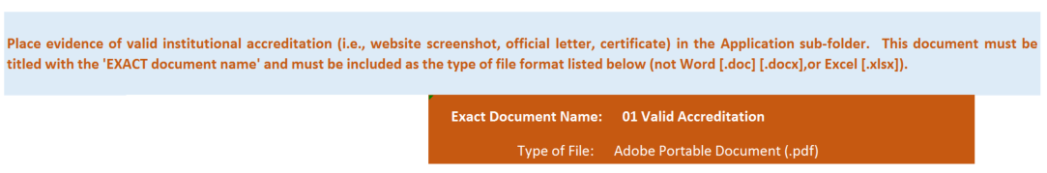

- Additionally, the Standard III-Personnel tab requires the Personnel Verification Report to be included in the Application sub-folder as evidence (i.e., 15 Personnel). The CoAEMSP sends this form once the key program personnel have been established. Please follow the instructions for submitting the required documentation for each of the key personnel as outlined on the Personnel page of the CoAEMSP website (https://coaemsp.org/personnel). The Personnel Verification will not be provided until all required personnel documentation has been submitted and CoAEMSP approved (if applicable). [see Standard III – Personnel tab for more details].

- The Application sub-folder will resemble the following picture as documentation for the Standard I tab is included. Please note, if the sponsor only awards an Associate Degree and does not have any articulation agreements, then the Certificate-Diploma, Baccalaureate Degree, Master’s Degree, and articulation agreements will not be required to be place in the Application sub-folder for Standard I.

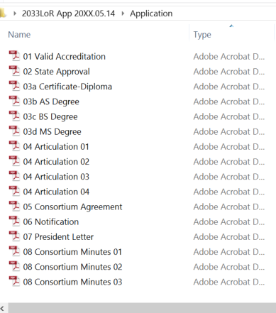
Application sub-folder for consortium Sponsors ONLY with the additionally requested documentation for Standard 1.

Application sub-folder with the requested documentation for Standard 1.

- Once all tabs have been completed, verify all the requested documentation has been gathered, properly named and formatted, and included in the Application sub-folder. However, each program’s Application sub-folder will vary some and will be based on the information for that specific program’s completed application. If every document was required to be included in the Application sub-folder from the Standard I and Standard III tabs in the application, then it would look like the following example except it would appear as a single column.
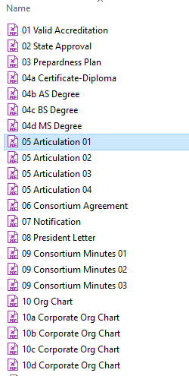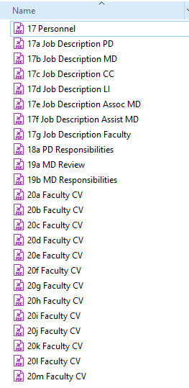

- Please review the application and required documentation with the Dean and any other required personnel. Please contact Lisa Collard (lisa@coaemsp.org or 214-703-8445 ext. 118) at the CoAEMSP with any questions.
Please Note: If the documentation is not named exactly as directed and in the correct file format, then the application will be returned and the program must fix the naming/formatting issues identified before the CoAEMSP will accept it. Cloud-based services (i.e., SharePoint, Google Docs, etc.) must not be used when completing the application or self-study template. This type of software tends to remove the built-in formulas from Excel.

- The application is ready to be submitted. Zip (compress) the entire main folder and upload the zipped (compressed) folder to the sponsor’s fileshare account (https://coaemsp.sharefile.com/Authentication/Login).

Please Note: Zipped files may look a little different depending on the version being used to zip (compress) the files.

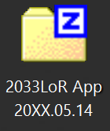

To zip (compress): right click on the main folder and select ‘Send to’, then select ‘Compressed (zipped) folder’. This will result in another folder with the same name as the main folder but with either a zipper or a ‘Z’ icon on the folder. This is the file that should be uploaded.

- CONGRATULATIONS!! Once the file has been uploaded, send (submissions@coaemsp.org) a separate email stating the LoR Application has been submitted.

Documents for LoR Application Checklist
Standard I: Sponsorship
- Evidence of institutional accreditation (letter, certificate, website screenshot)
- State Office of EMS approval (official letter, email)
- Preparedness Plan
- Sample certificate of completion or diploma
- Articulation agreement(s) (if applicable)
- Consortium agreement (if applicable)
- Notification of national accrediting agency of consortium (if applicable)
- Letter from CEO/President of sponsorship of consortium (if applicable)
- Consortium governing body meeting minutes for past 3 years (if applicable)
- Organizational chart of the sponsor
- Corporate organizational chart (if applicable)

Standard III: Personnel
- Personnel verification report from CoAEMSP
- Job descriptions for: Program Director, Medical Director, faculty (include Satellite Lead Instructor(s), Associate and Assistant MDs if applicable)
- CoAEMSP Program Director Responsibilities form
- CV/resume for each full-time faculty member
- CoAEMSP Medical Director Responsibilities form

