Step By Step Instructions
Request for Approval of a Satellite Location

The Request for Approval of a Satellite Location is an Excel document (software version 2016). All of the documents will require the file format to be an Adobe Acrobat Document (PDF), must be name exactly as specified, and require accurate hyperlinking.

Cloud-based services (i.e., SharePoint, Google Docs, etc.) must not be used when completing the self-study template. This type of software tends to remove the built-in formulas from Excel.

Please be sure if documents are scanned, they are positioned so it does not need rotating to view and the ability to rename the folder and/or documents are not restricted.

Please use the steps on the following pages as a guide in completing the program’s Request for Approval of a Satellite Location.

Highlight/Select the PDF icon below and then double-click to access the Directions for Creating a Single PDF Document.

***Remember to save your work once you completed the Excel template***

For questions or help composing the Request for Approval of a Satellite Location, please contact Lisa Collard (lisa@coaemsp.org or ext. 118)

- Create a main folder on your desktop titled with the Program #, name of the template, and Submission Date [yyyy.mm.dd] (e.g., 600XXX Request for Approval of a Satellite Location 20XX.12.01).

- Create one sub-folder for the requested documentation titled Documentation.

- Rename the Request for Approval of a Satellite Location Excel template the same as the main folder Program #, name of the template, and Submission [yyyy.mm.dd] (e.g., 600XXX Request for Approval of a Satellite Location 20XX.12.01) and place it inside the main folder. .

The main folder should look like the example below after completing Steps 1-3 above.

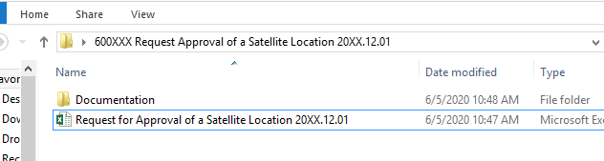
Single sub-folder
Main folder
Renamed Excel Template

- Open the Request for Approval of a Satellite Location Excel template and complete the light orange highlighted cells in the Main Program section of the Excel template (rows 25-36).
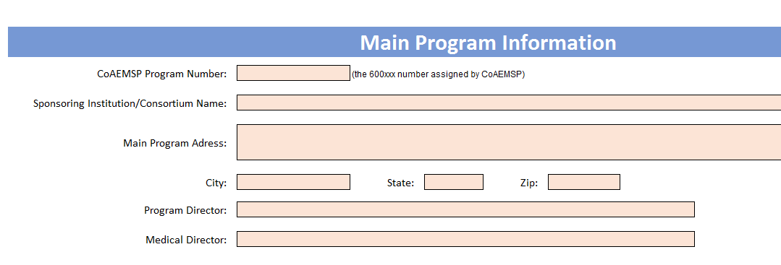
Orange highlighted cells in rows 25-36 of the Excel template

- Scroll down to the Satellite Location Information section and answer each of the questions in order beginning with question 1.
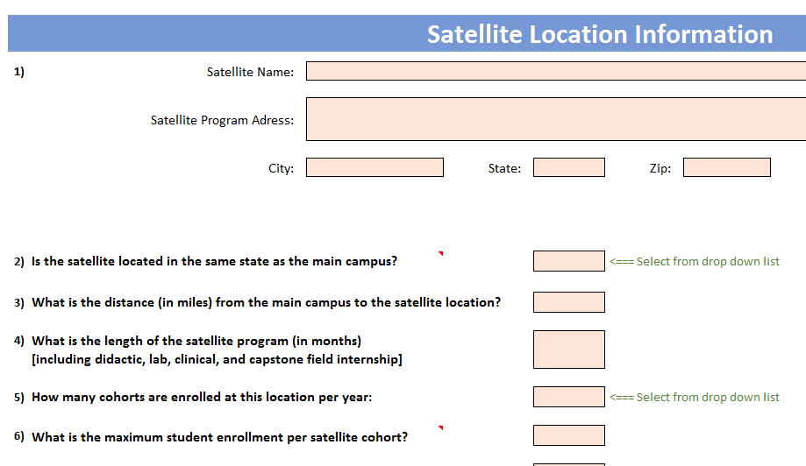
Question 1

- Once all questions have been answered, gather the specified documentation. The dark orange section identifies the specific name and format required to be used when including the files in the Documentation sub-folder. The Personnel Verification is the first document required to be placed in the Documentation sub-folder. This document can only be obtained by contacting Lynn Caruthers at the CoAEMSP.

The document MUST be titled with the 'EXACT document name' (i.e., 01 Personnel) and the type of file format MUST be an Adobe Portable Document (PDF) as directed in the dark orange section (rows 83-85).

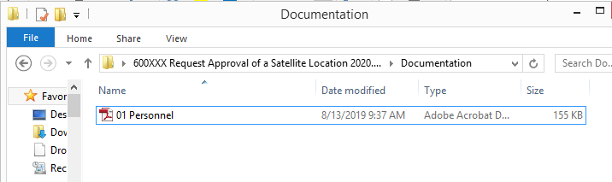
Documentation sub-folder with the Personnel Verification (i.e., 01 Personnel).

- Place the cursor over the 01 Personnel link within the Request for Approval of a Satellite Location Excel template, right click and select edit hyperlink, locate and select the 01 Personnel evidence within your Documentation sub-folder. This will need to be done for all links in the template. If you are having trouble editing the link or have any questions, then contact Lisa Collard (lisa@coaemsp.org or ext. 118) at the CoAEMSP. Please Note: If the documentation is not correctly compiled, or the document is not named exactly as directed and in a PDF format, the Request will be returned.



- For the remaining satellite documents, scroll down to the next orange section and double-check that each required document has been named correctly, the type of file format is an Adobe Portable Document (PDF), placed in the Documentation sub-folder, and link that file to the template. If there are any items that contain more than one page for the evidence, then scan all documents together and create a single PDF document and name it correctly and place it in the Documentation sub-folder. Please Note: Directions for Creating a Single PDF Document can be accessed on page 1 of these instructions by double-clicking on the PDF icon in green.

The Documentation sub-folder should look like the example on the next page if the program is required to provide every document. However, there may be items that are not required based on how the program has answered the questions. Therefore, the Documentation sub-folder may be slightly different.

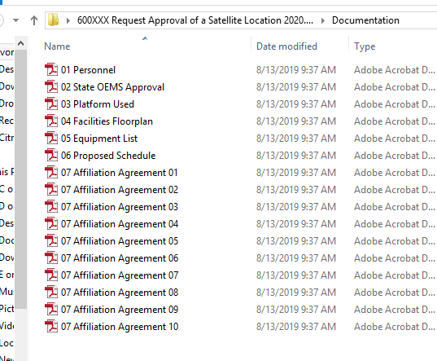

- Please review the Request for Approval of an Satellite Location to ensure it is complete, as well as, the required documentation to verify the information provided is accurate and has been named and formatted correctly. Please also review the information with the Dean and any other required personnel prior to submission.

- Once the requested all requested documents have been included in the Documentation sub-folder, zip (compress) the entire main folder, and send it electronically (email it) to lynn@coaemsp.org. Please Note: Zipped files may look a little different depending on the software version being used.

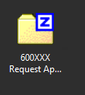

- CONGRATULATIONS!! You will receive confirmation of receipt, as well as, further instruction (if any) from Lynn Caruthers at the CoAEMSP.

